CONFIGURING EXCHANGE 2013

TO

HCP FOR SMTP JOURNAL ARCHIVING

Table of Contents
1.Create Exchange Contact for HCP 3
2.Create Exchange Contact for HCP 7
3.Create Journal Rules 16
3.Troubleshooting 19

1.Create Exchange Contact for HCP

In this step, an Exchange Contact is created for the HCP Namespace. This contact is later used in the Journaling rules.

Step 1:
Log on to the Exchange Admin Center using a web browser

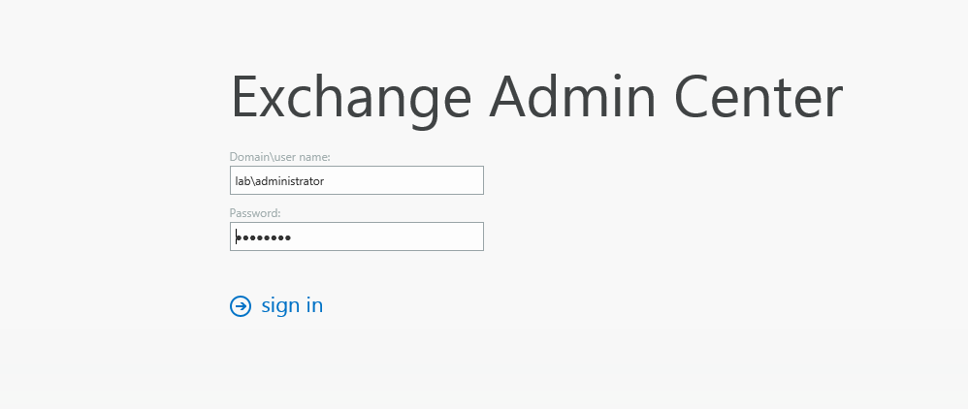

Step 2:
Navigate to Recipients > Contacts

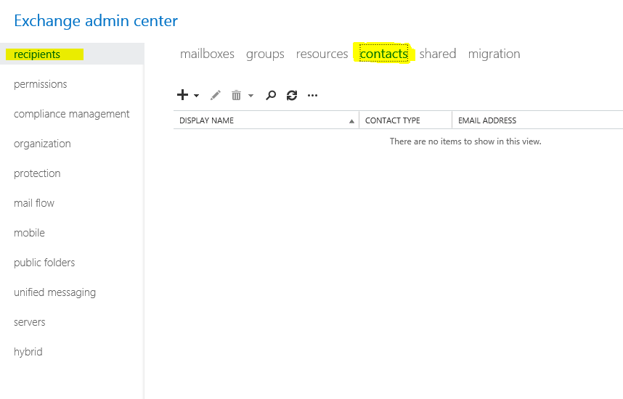

Step 3

- Add a new contact (+)
- Specify the contact name and Alias
- Add an external email address
- Save the new contact information
Note: For the External Email Address, the @ domain name should be the FQDN of the HCP SMTP Enabled namespace created on HCP for Exchange

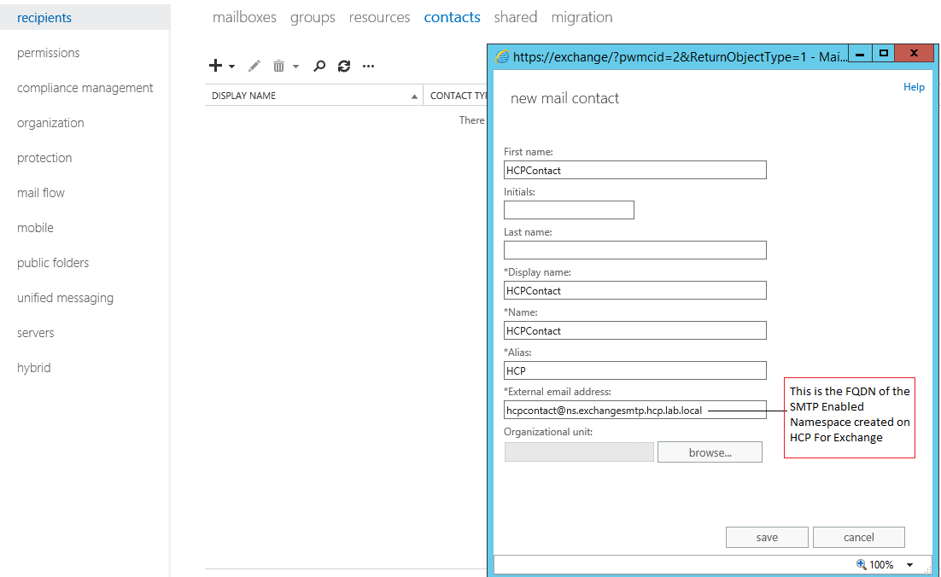

Once the contact is saved it will appear as below.

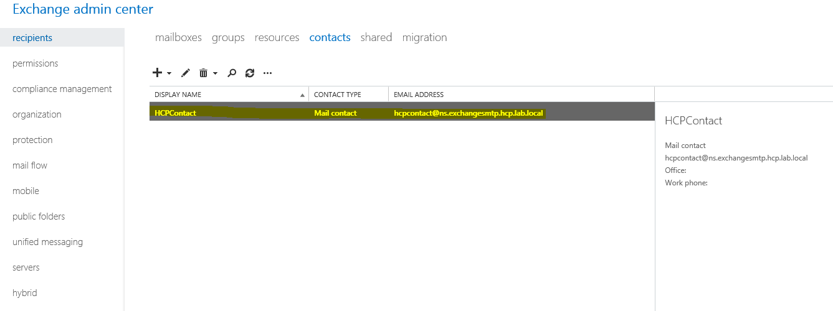

2.Create Exchange Contact for HCP

In the next section the send connector is created.
Step 1
. While still in the Exchange Admin Center
Navigate to Mailflow > Send Connector

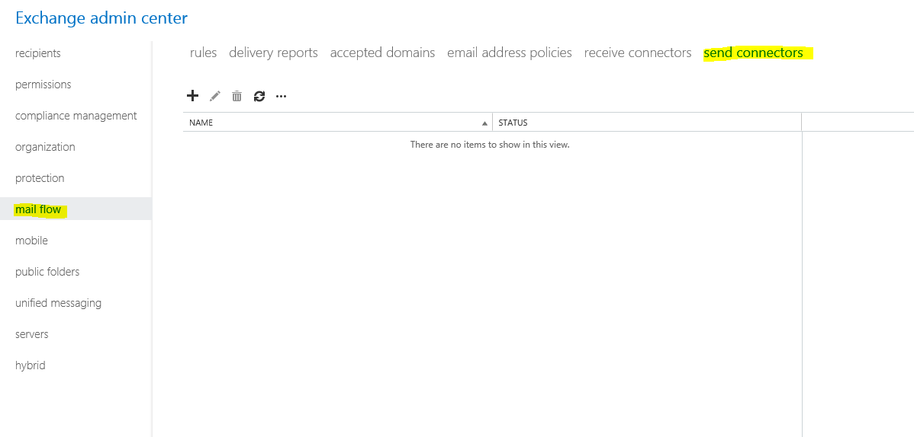

Step 2
Add a new send connector

Add a new send connector (+)
On the “NAME” specify a unique meaning full name. This is to ensure that if troubleshooting is needed the send connector specific to the HCP can be easily identified in the Exchange send connector log file.

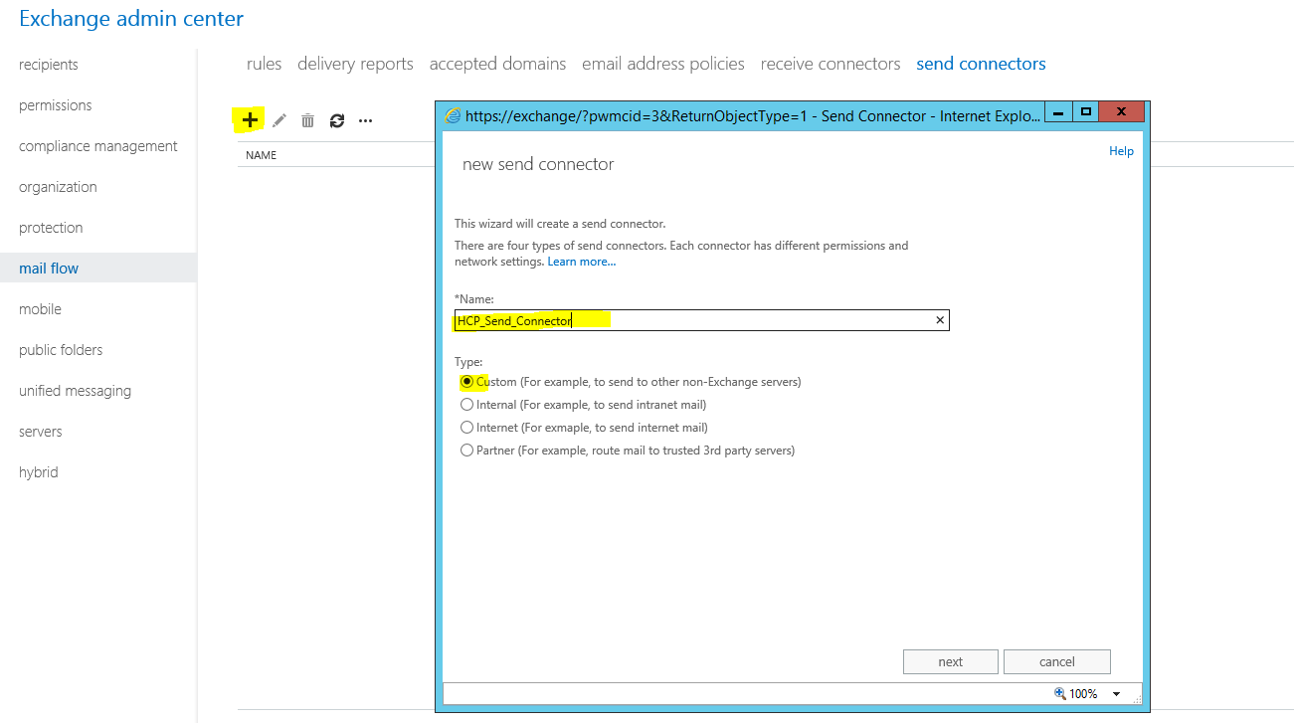

Click NEXT

Step 3

One the next configuration page of the send connector:
- Select the “Route through Smart Host” radio button
- Click add (+)
- For the name of the smart host add the FQDN of the HCP. Note the namespace FQDN can be used here as well.
- Save
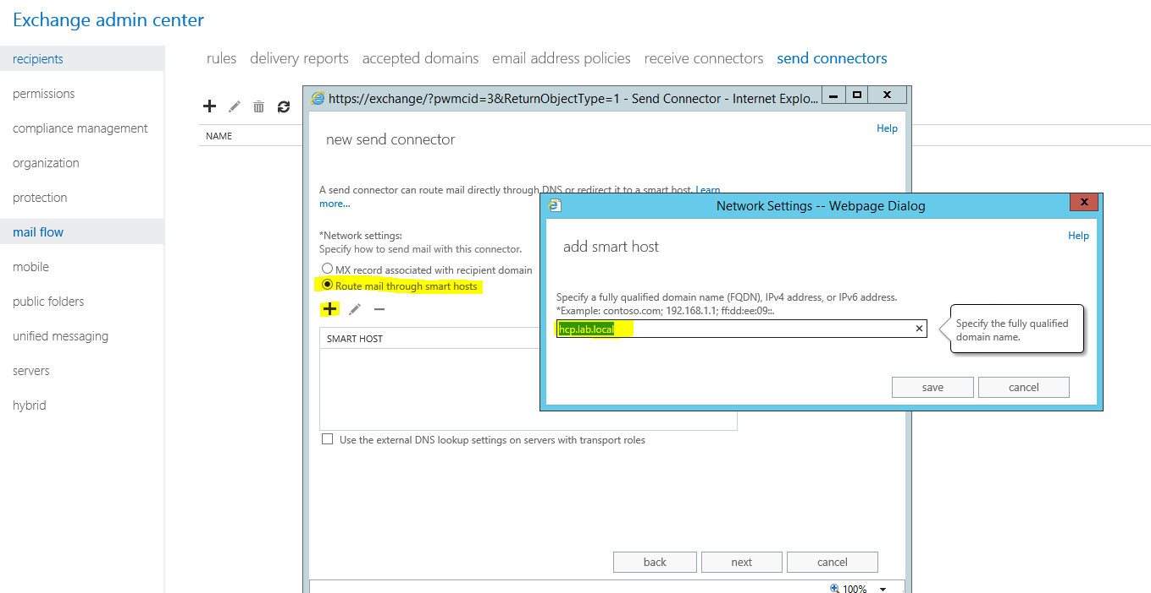
The smart host will be added
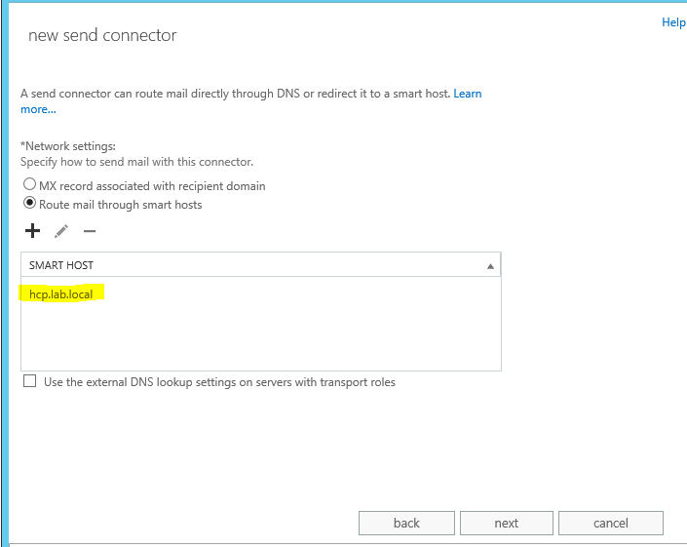
Click Next
Step 5

The smart host authentication screen select “None”
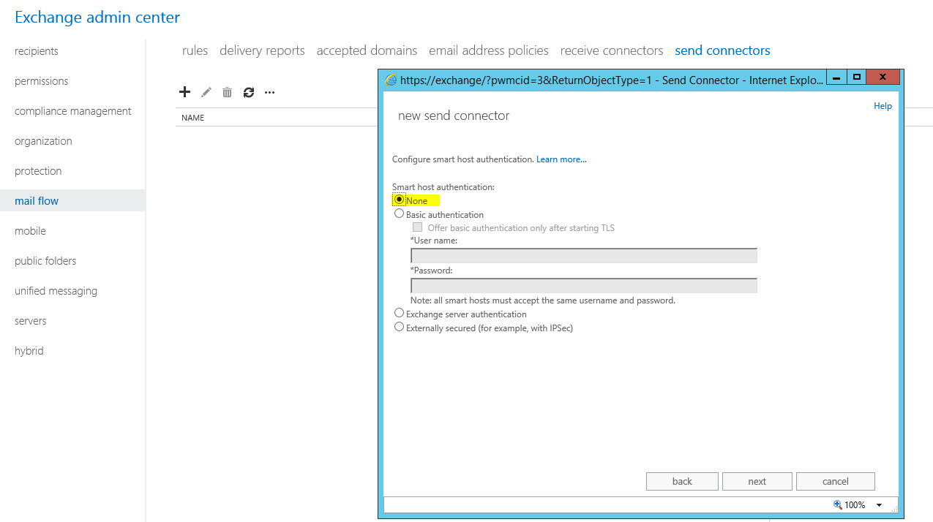
Click Next

Step 6
Specify the Address Space
- Click add (+)
- For type : SMTP
- For FQDN : Enter the FQDN of the SMTP Enabled namespace created on HCP.
- For Cost : Leave at default of 1.
- Leave the check box for “Scoped Send Connector” unchecked

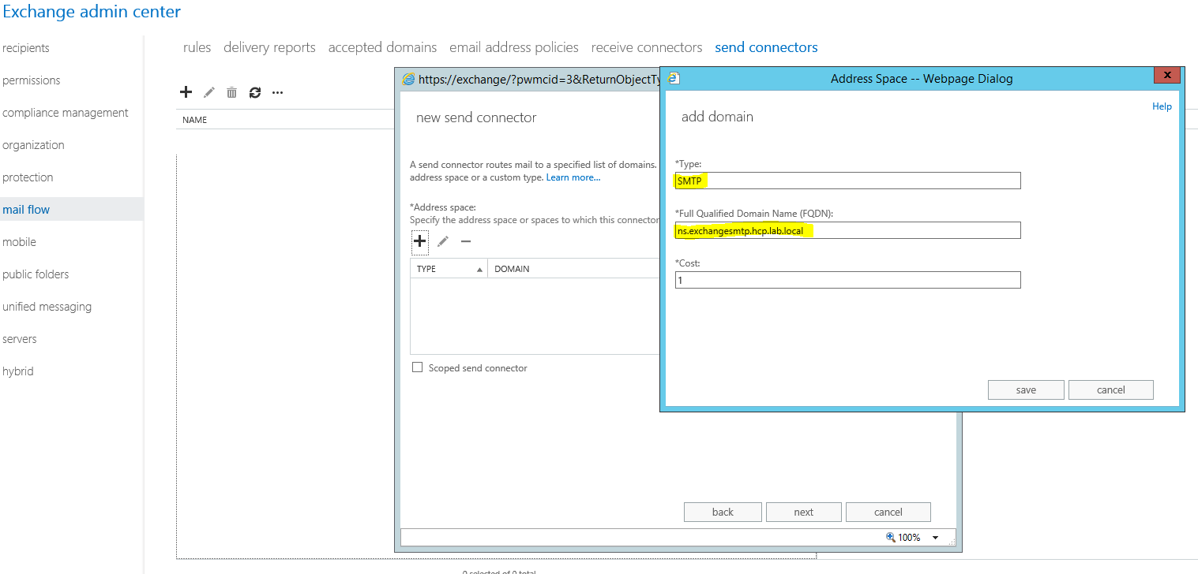

Click save and Next

Step 7
Add source Exchange servers (These are the exchange servers that will use the send connector to send to hcp)
- Click Add Source server (+)
- Select the relevant servers and click add
- Click ok
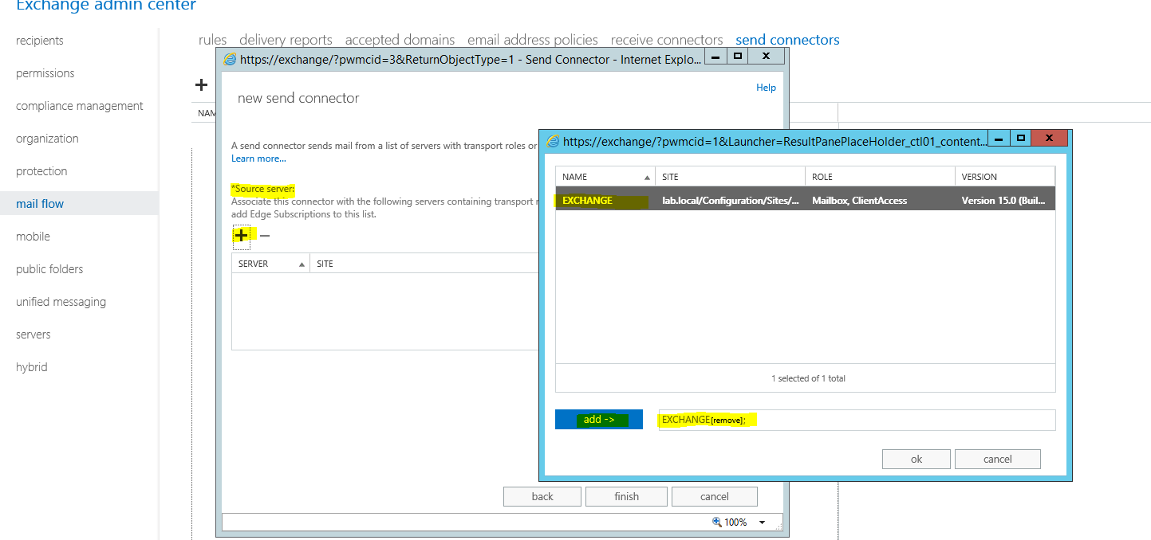

Step 8 :Click Finish
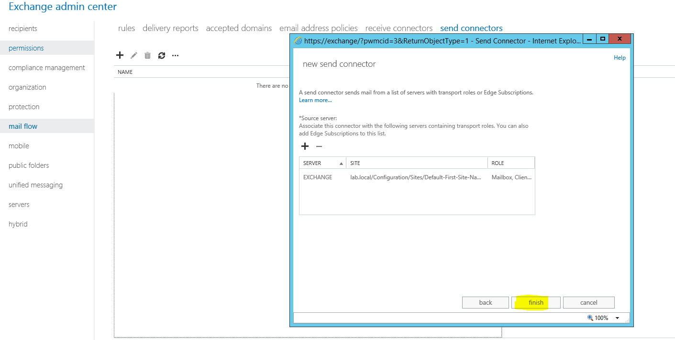
Step 9
The next Step is to edit the send connector to add a few more parameters to the send connector
- Still on the send connector page
- Select the relevant send connector
- Click on Edit button (highlighted in yellow below)

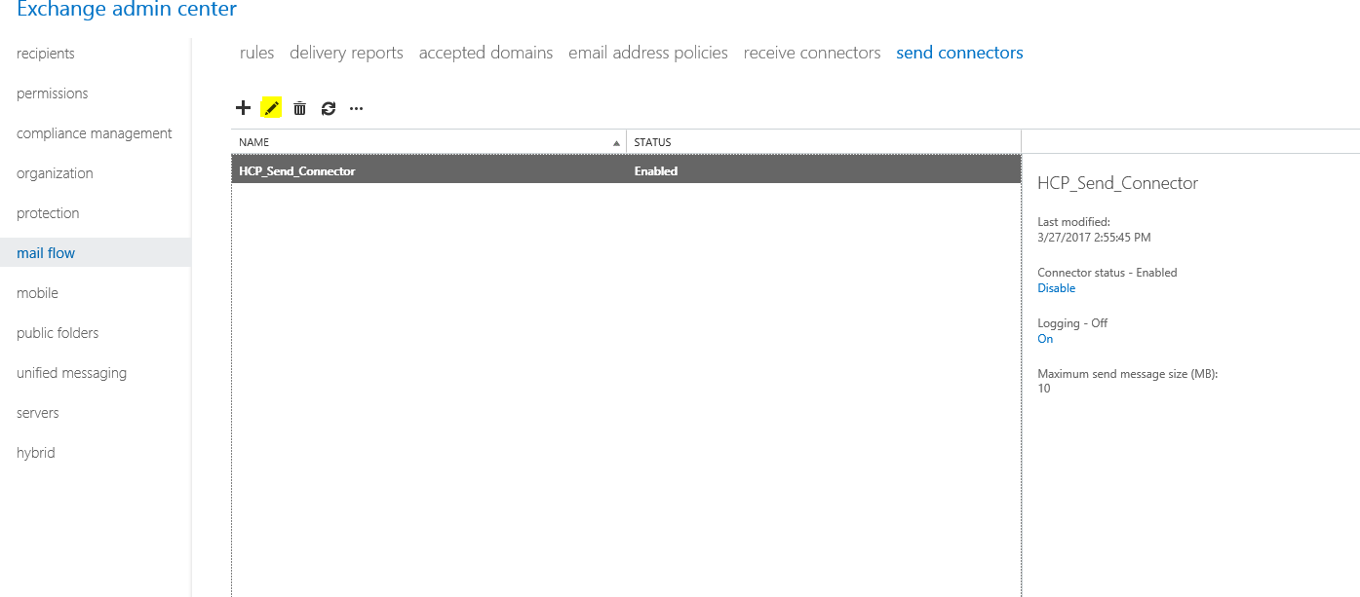

On the GENERAL TAB
- Connector Status: Enable must be checked
- Protocol Logging: Set to Verbose
- Maximum send message size: Set by customer requirements

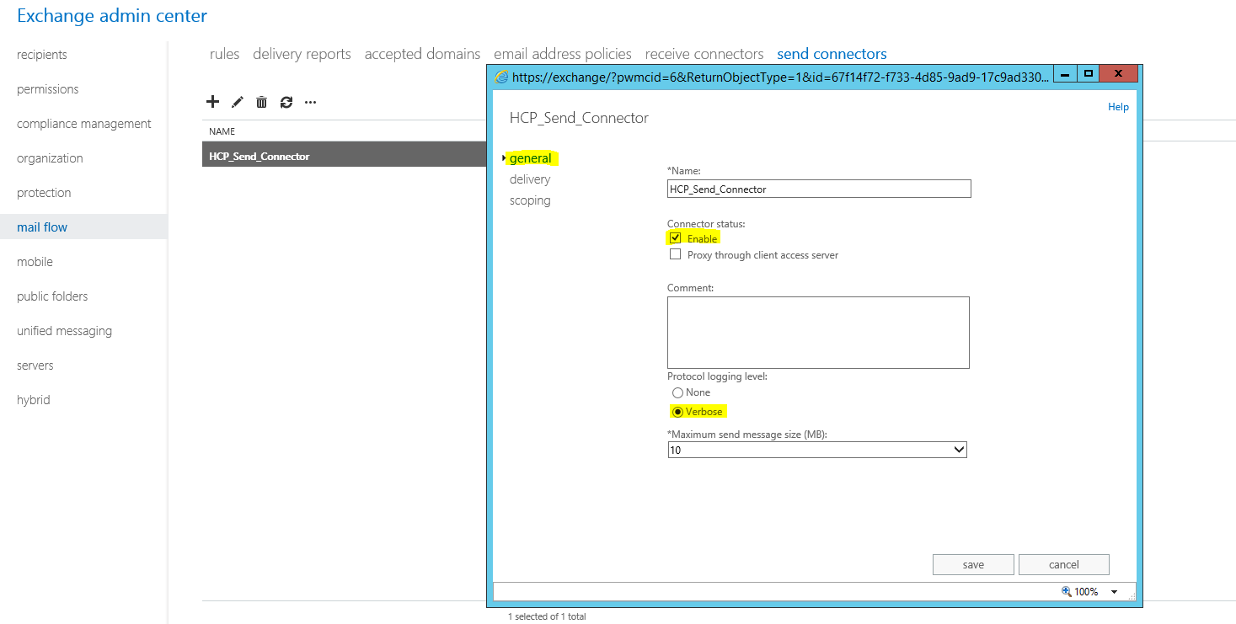

While still in the edit page of the Send Connector
Click on the scoping TAB
At the bottom of the page in the FQDN space enter the HCP SMTP enabled namespace name then click save
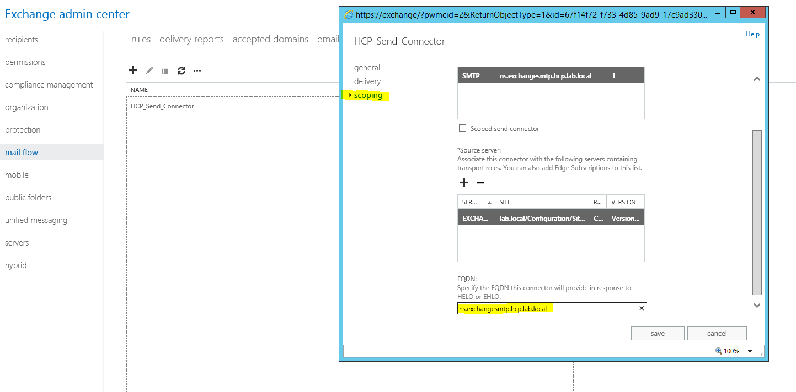

3.Create Journal Rules

In this section, Journal rules are created to enable user mailboxes be journaled to HCP. Please note that there are two ways of Journaling they are both shown in the sections below.

Exchange 2013 provides the following journaling options:

- Premium journaling: Premium journaling enables the Journaling agent to perform more granular journaling by using journal rules. Instead of journaling all mailboxes residing on a mailbox database, you can configure journal rules to match your organization's needs by journaling individual recipients or members of distribution groups. You must have an Exchange Enterprise client access license (CAL) to use premium journaling.

- Standard journaling: Standard journaling is configured on a mailbox database. It enables the Journaling agent to journal all messages sent to and from mailboxes located on a specific mailbox database. To journal all messages to and from all recipients and senders, you must configure journaling on all mailbox databases on all Mailbox servers in the organization.

Premium journaling:

In order to set up this type of Journaling
In the Exchange Admin Center
Navigate to the Compliance Management TAB and select Journal rules
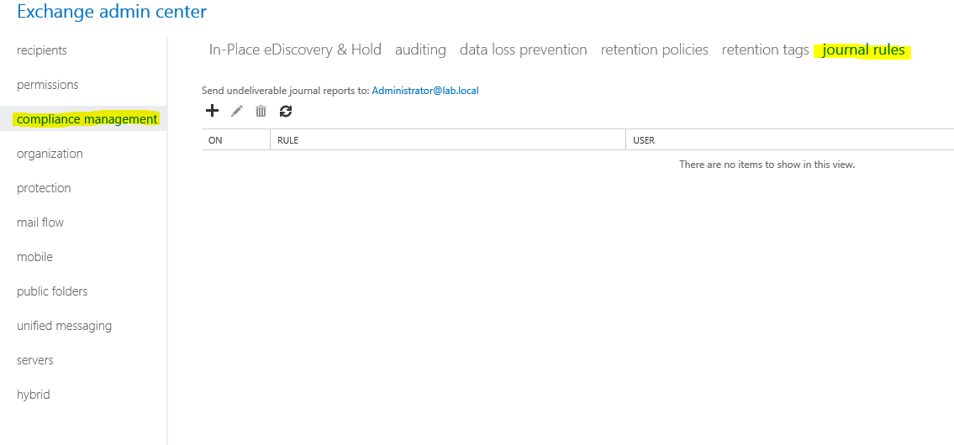

Click on the add (+) button
For the fields below specify
- Name: Specify a meaningful name for the Journal rule that can be easily identified if troubleshooting is required
- “If the message is sent to or received from”: Specify the desired value based on customer requirements
- “Journal the following messages”: Specify the desired value based on customer requirements
- “Send Journal reports to”: Specify the email address created in the contacts section (See section 1 of this document) this is the email address for the hcp contact.

Standard journaling:
This is enabled at the database layer of the exchange and all mailboxes that reside on the selected databases are journaled. This is up to the customer to decide.
To enable this
On the Exchange Admin Center
- Navigate to Servers > Databases
- The select the database and click the edit button a new window will open
- Click on the maintenance tab and add the HCP Contact by selecting browse you will find the contact then add then click save.

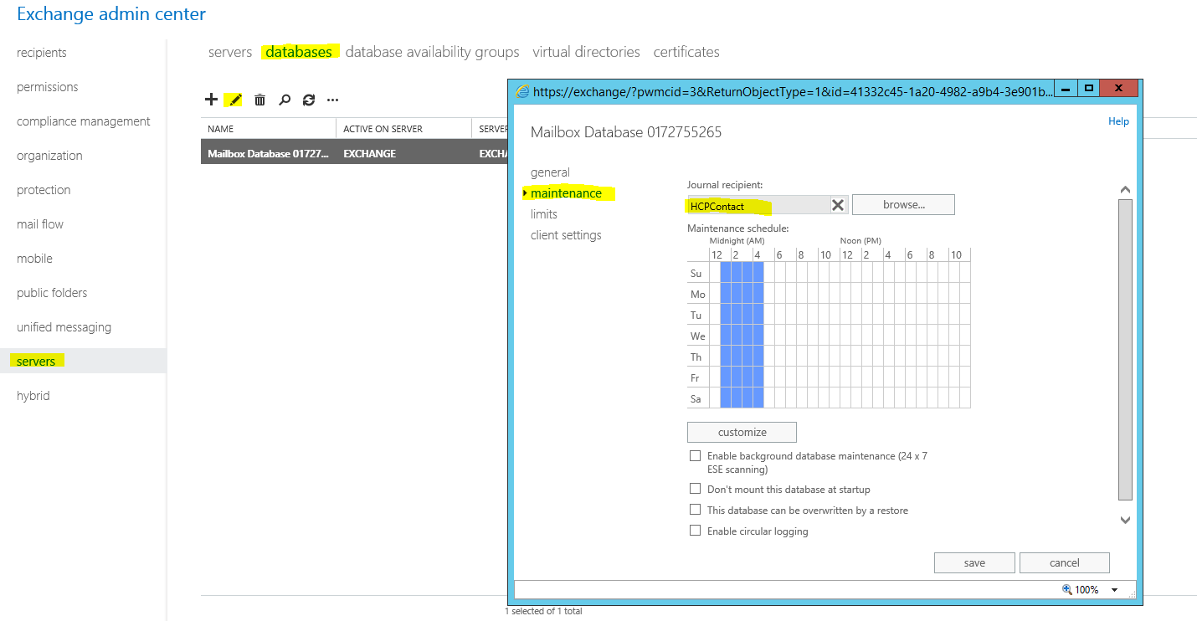

3.Troubleshooting

Exchange Logs

The exchange logs location may vary if the Exchange administrator has changed the output file location.
To ensure that you are viewing the relevant exchange logs see below:
- Log on to the Exchange Admin Center
- Navigate to Servers > Servers
- Highlight the relevant server and select edit
- Navigate to Transport Logs

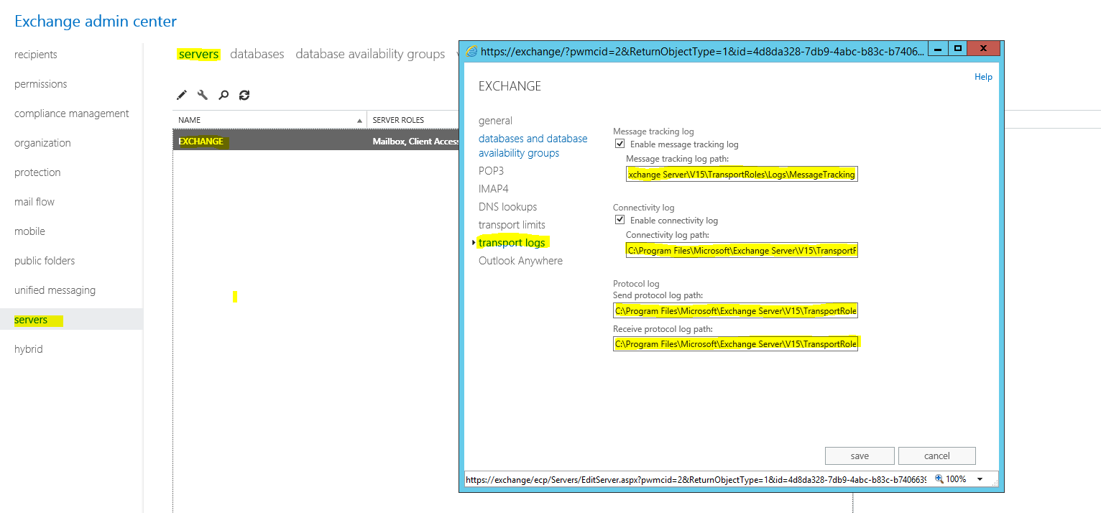

TCP Dumps on HCP
If for some reason the HCP is not receiving objects. You can run a TCP Dump on the HCP to check if the SMTP traffic is hitting the HCP.
Using the secure SSH keys log on to the HCP with root
Run the command on HCP while sending a mail from exchange.
tcpdump -i <NETWORK INTERFACE>-s 0 -n |grep smtp

If this does not work run a Telnet test to HCP Namespace on port 25 refer to the below link for more assistance
https://technet.microsoft.com/en-us/library/bb123686(v=exchg.150).aspx

