ETL setup:
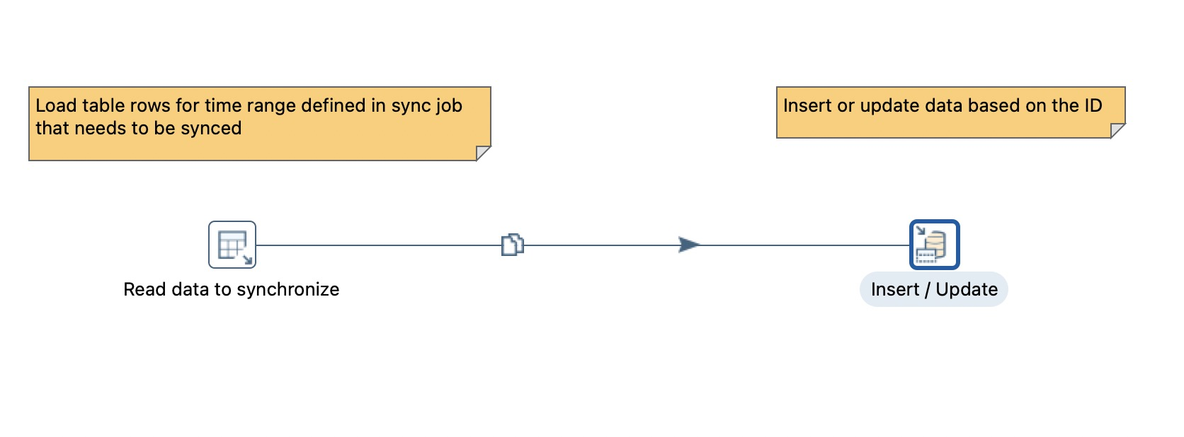

Select query in Table Input:
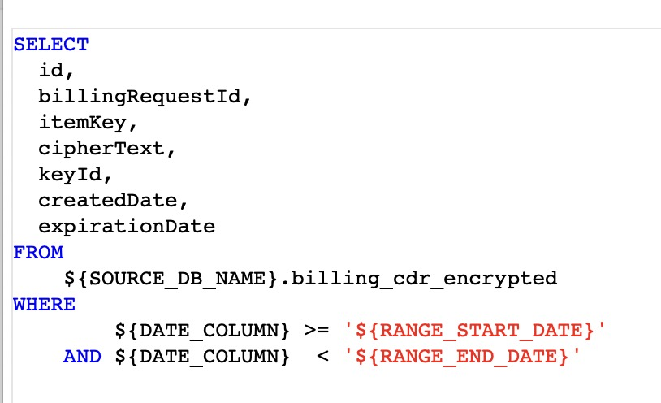

Value in Source:

after running ETL, value in Destination:

