Outline: [Validating volume expansion for replicated Volumes via the Hitachi Ops Center Protector v7.3.1]
Keyword: [ops center management, hitachi vsp 5000 series]
Author: [Tanmoy Panja]
Due Date: [12-17-2021]
Publish Date: [12-20-2021]
Buyer Persona: [Enter Targeted Reader and/or Buyer Persona]

[Validating volume expansion for replicated Volumes via the Hitachi Ops Center Protector v7.3.1]

Objective
- Validate the enable/disable SOM 1198 setting for VSP 5600 arrays using Protector as well as CCI.
- Validate the expansion of replication P-VOLs and S-VOLs for GAD/True Copy/HUR for VSP 5600 arrays using Protector GUI.

Introduction
Protector 7.3.1 supports setting (enable/disable) System Operation Modes (SOMs) on the array to enable expansion of volumes that are currently being replicated using replication suspend as opposed to replication tear-down. During the expansion the replications will be paused, then the PVOL(s) and SVOL(s) will be expanded and finally the replication will be resumed.
The SOM(s) required for replication expansion must be enabled on both arrays (source and destination). To configure this via Protector, the array must support SOM configuration from CCI/Raidcom.

Test Methodology
- Ops Center Protector Master node was installed on a virtual machine (VM) server using the standalone installer. Ops Center Protector ISM node was installed on a separate virtual machine (VM) server using the standalone installer. CCI (Command Control Interface) was also installed in the ISM Node.
- The two VSP 5600 storage systems were discovered as block storage nodes in the Protector UI.
- Configure one Block Host node that represents the replication P-VOLs.
- One GAD replication pair was created on these storage systems using Protector. Both P-VOL(s) and S-VOL(s) were dynamic (created in a pool).

Environment Configuration Layout
The overall environment layout for the testing is shown in the following diagram:
Figure 1 – Environment Layout (GRR)
As shown in the previous diagram, the test environment consisted of the following:
Software Components | Software | Version | OS version
 | Protector (Master & ISM) | 7.3.1.90691-R7.3 | Microsoft Windows Server 2019 (64-bit)
 | CCI | 01-65-03/04
 | VMWare vCenter | 7.0.2.00500
Server Components | OS | CPU | RAM
Hitachi Advanced Server DS220 1S5BZZZ0014 | VMware ESXi, 7.0.2, 17630552 | Intel(R) Xeon(R) Gold 6140 CPU @ 2.30GHz | 127 GB
Hitachi Subsystem Components | Storage Model | Firmware Version
 | VSP 5600 | 90-08-01/00

Test Setup
Configuring replication Expansion using the Protector UI
To configure replication Expansion, complete the following steps:
- From the Protector UI, navigate to the Storage screen for each Block Device node involved in the replication as shown in the following screenshot:
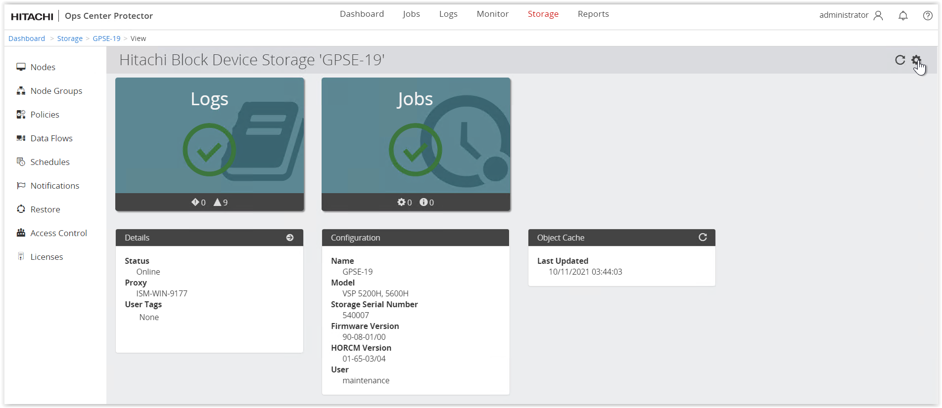Figure 2 – Protector Storage wizard

- Verify the existing GAD replication pair status as “PAIR” as shown in the following screenshots:
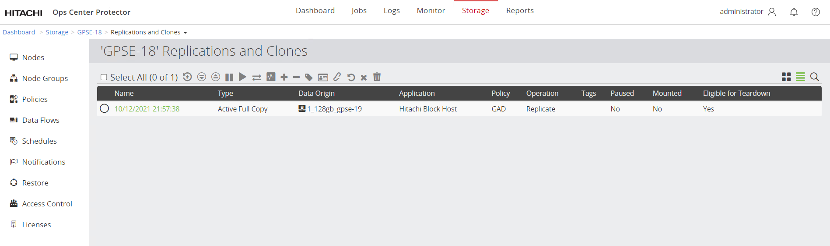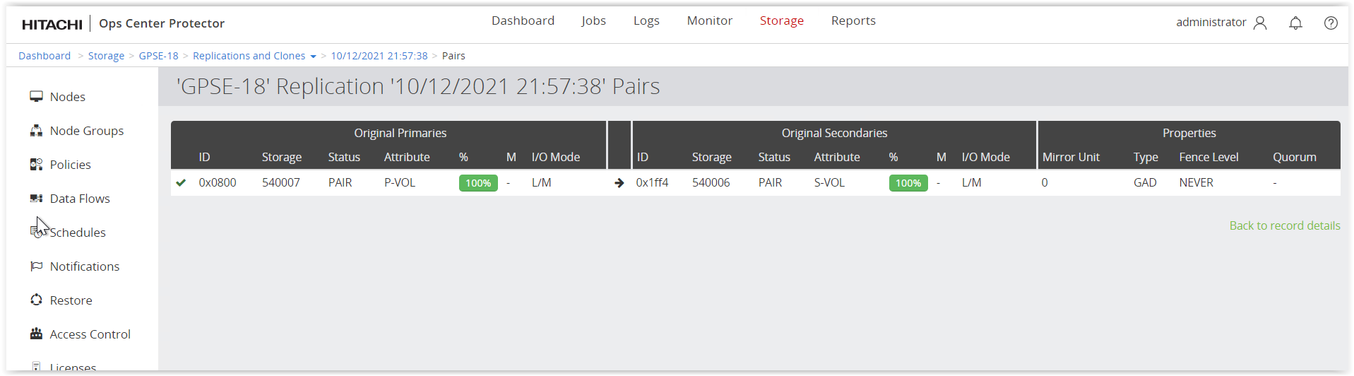
Figure 3 – Storage replication wizard
- Open the Block Device Advanced Settings dialog by clicking on “” icon as shown in the following screenshot:
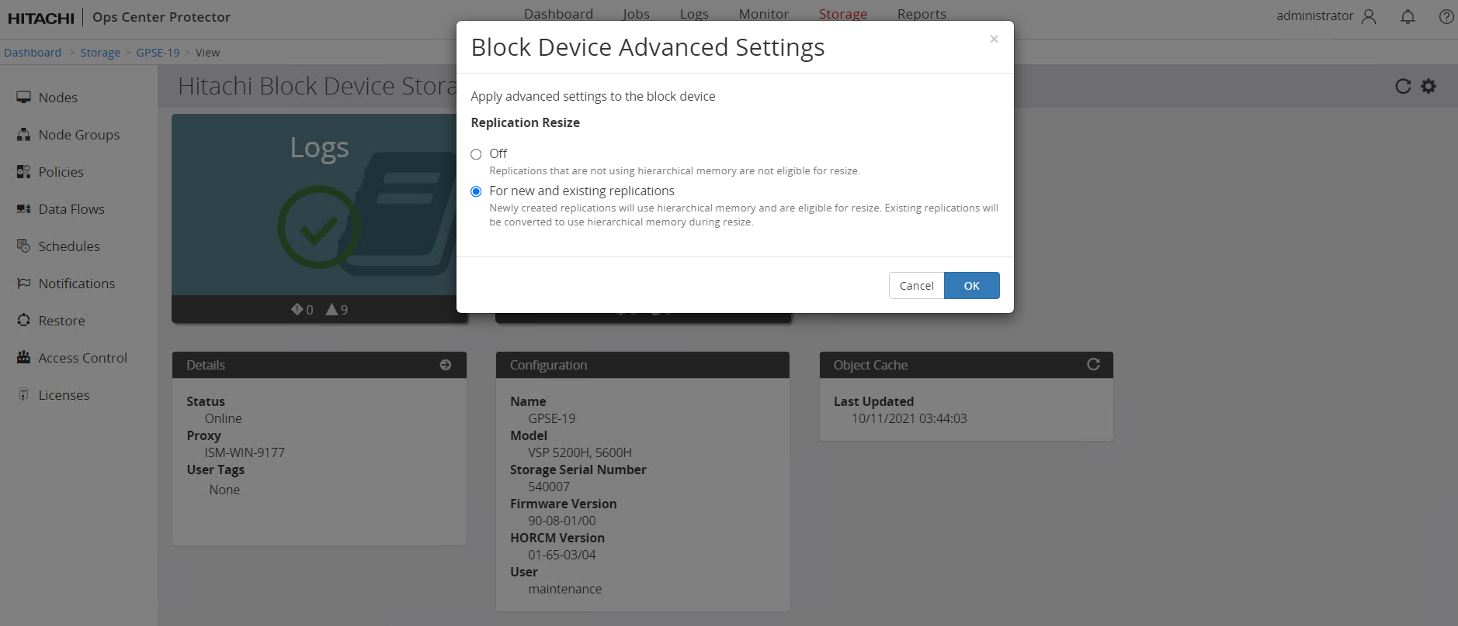
Figure 4 – Block Device Advanced Settings wizard
- Select For new and existing replications radio button and click on OK as shown in the following screenshot:
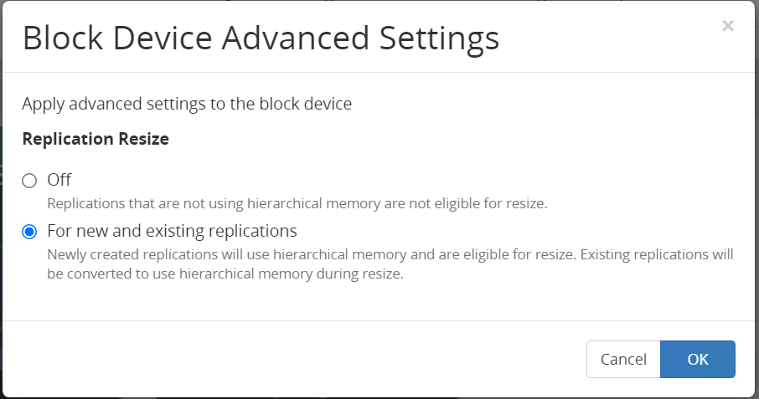
Figure 5 – Block Device Advanced Settings wizard
- Navigate to the Logs screen and check the log message as shown in the following screenshot:
Figure 6 – Logs wizard
- SOM 1198 will be enabled for VSP 5600 arrays. Verified the same using CCI for VSP 5600 arrays.
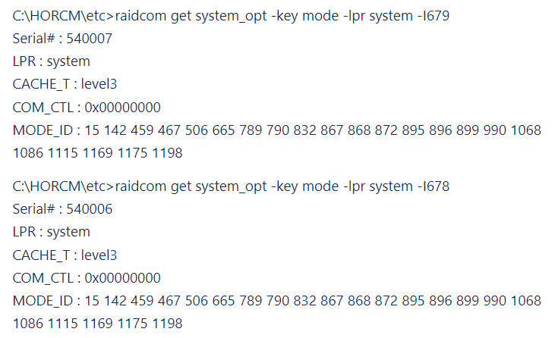
Figure 7 – CCI output

Test Implementation
Once Block Device Advanced Settings for each Block storage node is configured properly, we completed the following procedure to resize logical devices. This is represented by the Block Host node that are part of a replication
- Navigate to the Details screen for the Block Host node that represents the replication P-VOLs as shown in the following screenshot:
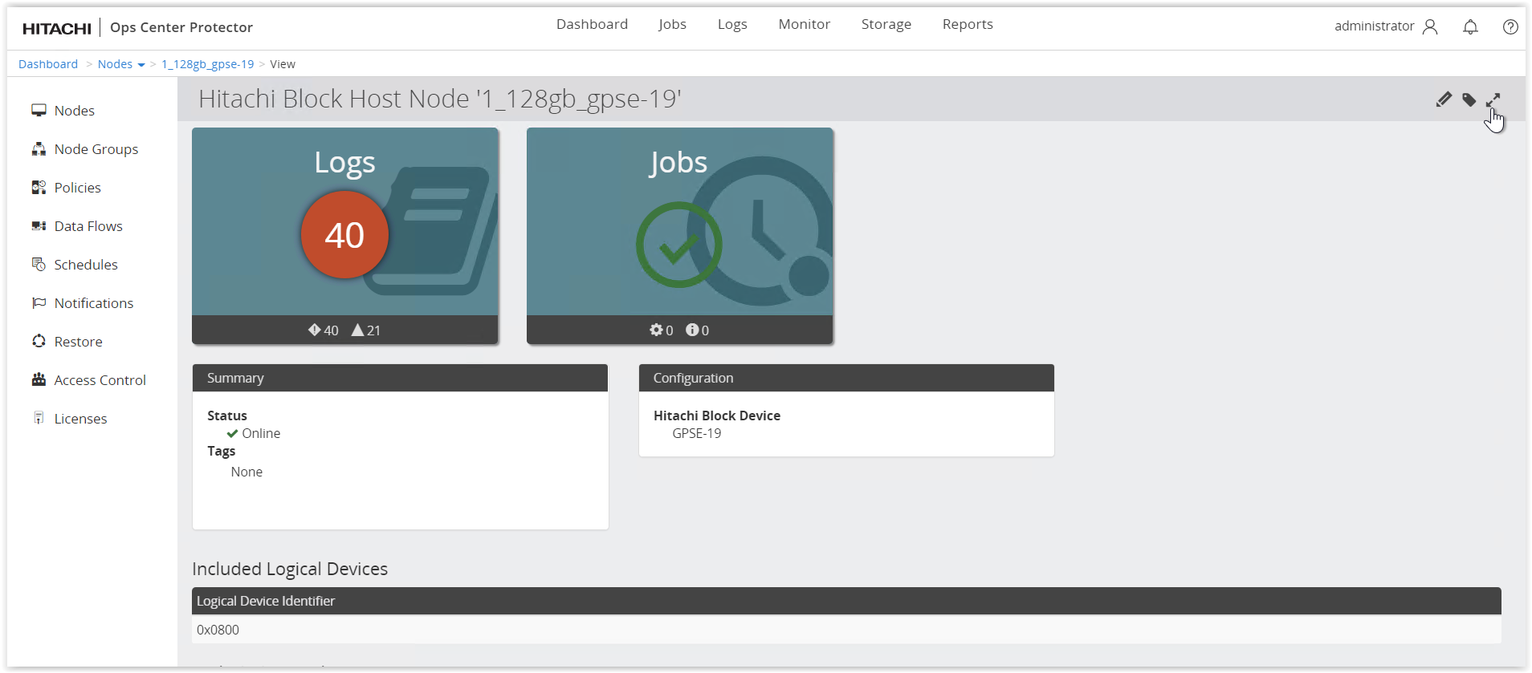
Figure 8 –Details screen of the Block Host node

- Open the Expand Logical Devices dialog using the tool bar item. Select the logical device that require expansion and click Next as shown in the following screenshot:

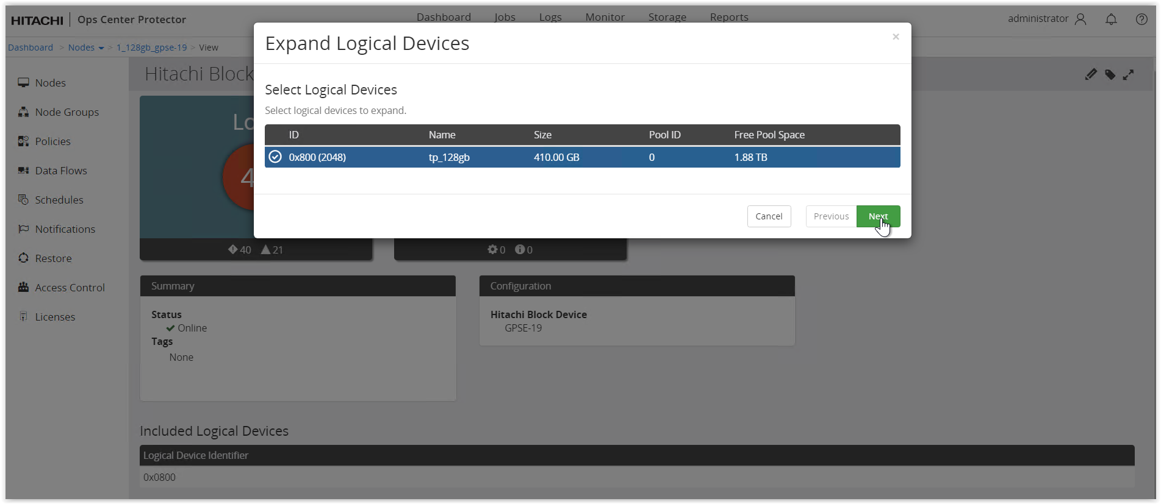
Figure 9 – Expand Logical Device wizard

- Specify a new size for the logical devices to be expanded by in units of GB or TB and click on Finish as shown in the following screenshot:
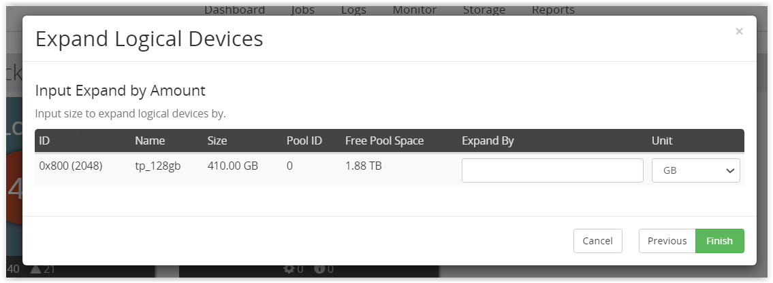Figure 10 – Expand Logical Devices - Input Expand by Amount

- Await completion of the resulting job and click on Job screen as shown in the following screenshot:
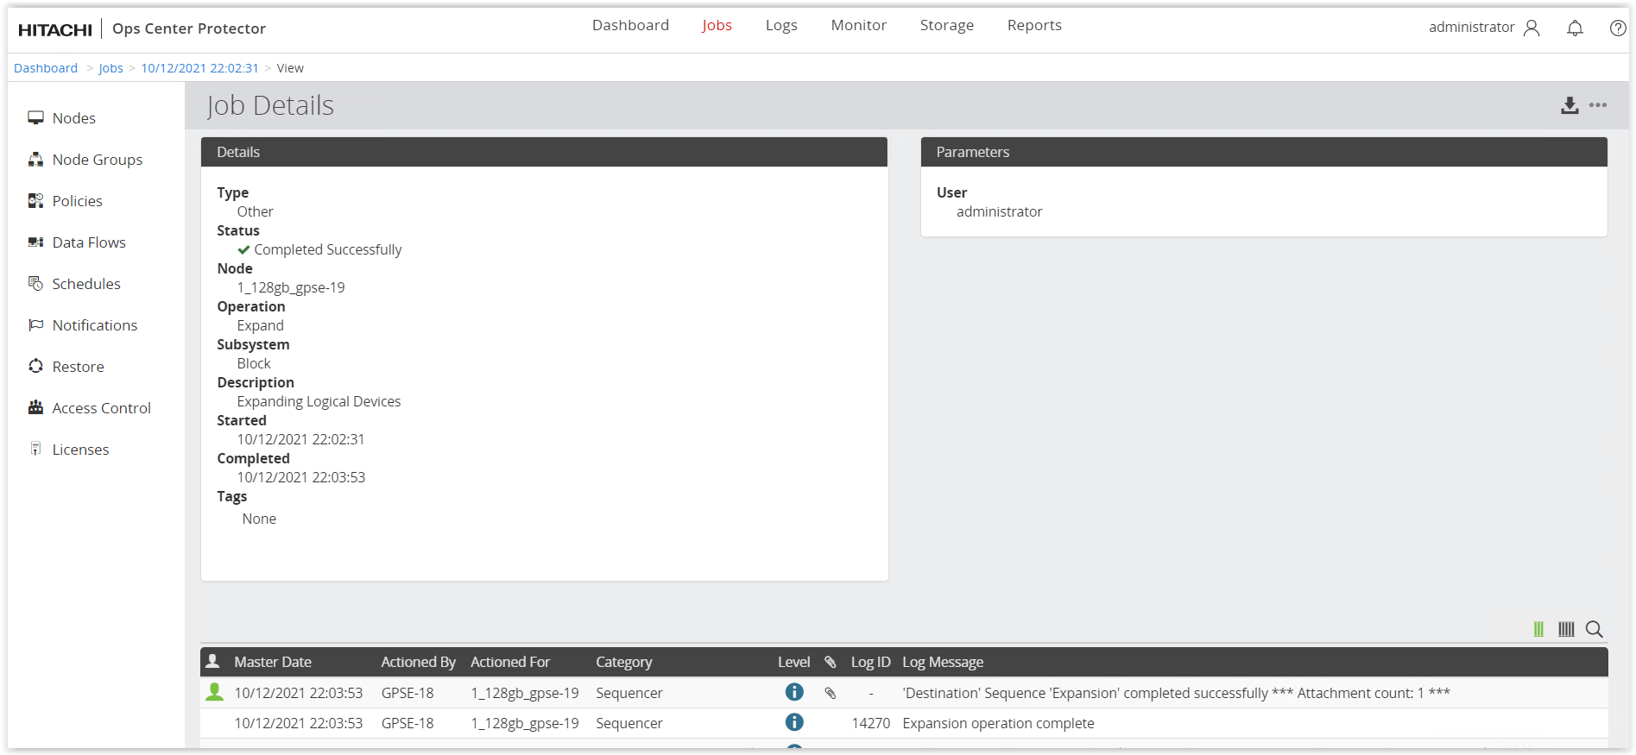Figure 11 – Job Details – Replication Expansion
- To disable SOM 1198 for VSP 5600 arrays select Off radio button and click on OK as shown in the following screenshot:
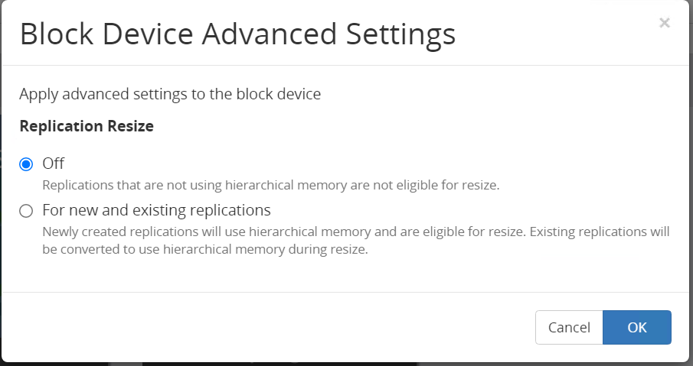
Figure 12 – Disable SOM 1198 – Advanced Settings

Limitations
- Presently protector only supports only remote replications (True Copy/HUR/GAD)
- Supports only Block Host source nodes
- Supports only dynamic logical devices (created from pools)
- Requires manual step(s) if either array does not support SOM configuration from CCI/Raidcom (eg. VSP G1000)

Test Conclusion
Based on the test results, we came to the following conclusion:
- SOM settings of storage system can be modified via Advanced Settings dialog in Protector UI.
- Both the PVOL(S) and SVOL(S) of the replication are expanded to the same size using Protector UI.

