Using HDID I am currently moving one single docx file to HCP Namespace. Please see the screenshot for your reference.

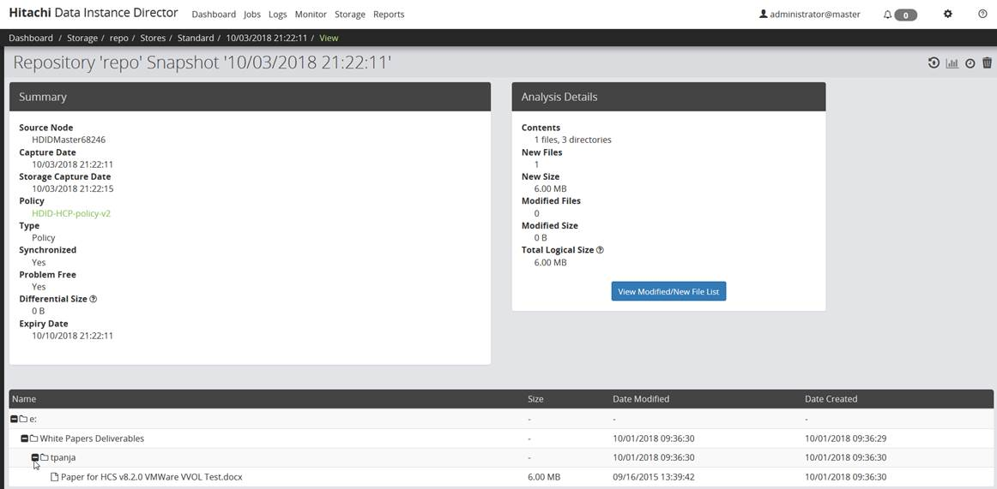

HDID Namespace which is actually HCP namespace.

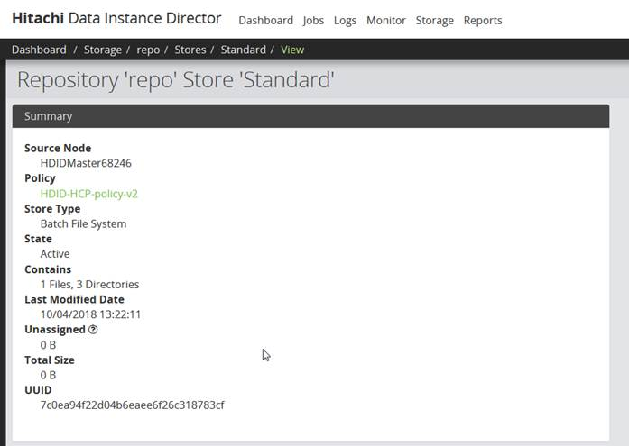

Under tenant “hdid” there is only single namespace in HCP.

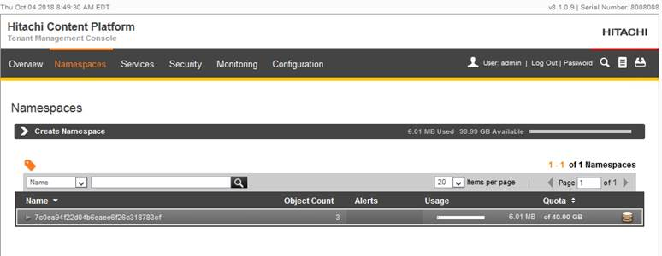

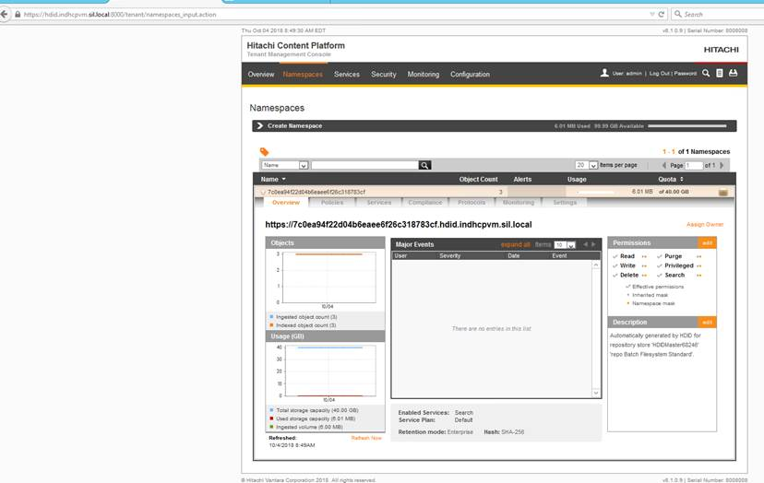

Used same namespace “7c0ea94f22d04b6eaee6f26c318783cf “ during data-connection in HCI:

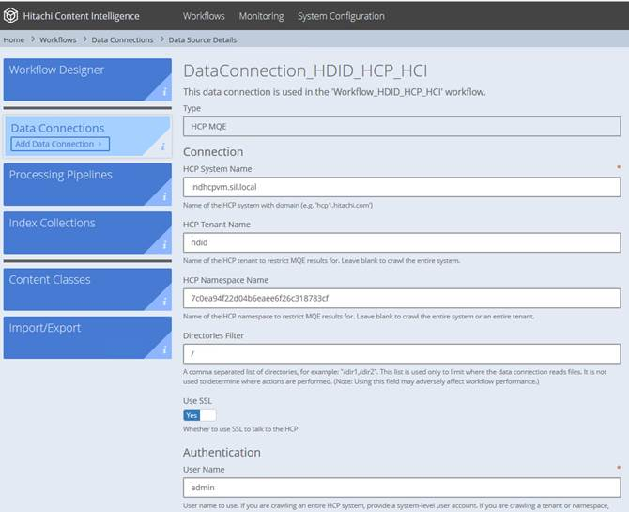

Also I have imported same bundle file in my HCI as discussed yesterday and have not done any modification except Data-Connection. Ran Work flow successfully.

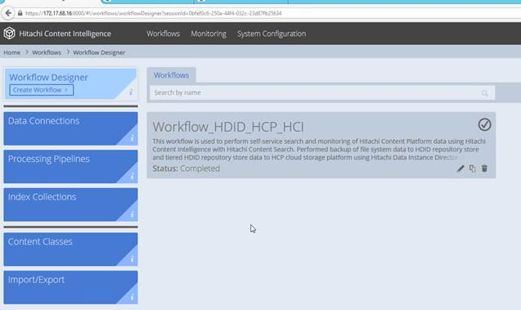

But when trying to access Content Search, it is showing all data from previous generated namespaces instead of present docx single file.  Why Content search is not showing any data related to current namespace? Am I missing something here?

