Job:

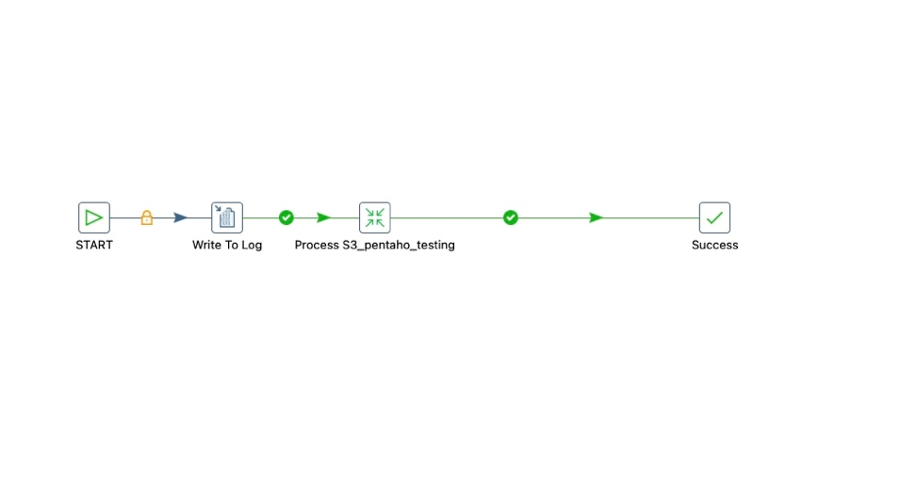
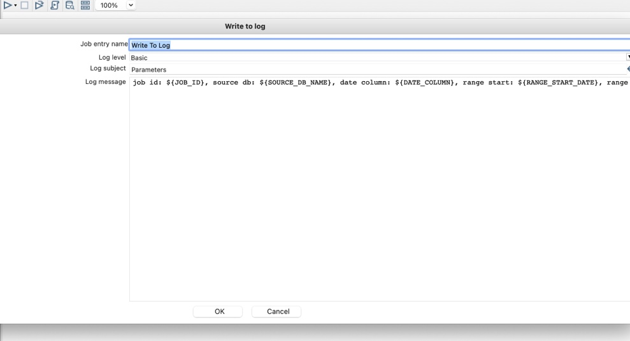

Parameter is getting passed-
2023/12/05 11:30:22 - Write To Log - Starting job entry
2023/12/05 11:30:22 - Parameters - job id: 144892983, source db: ods, date column: createdDate, range start: 2023-12-03 00:00:00, range end: 2023-12-04 00:00:00, file location: ${S3STORAGEFILELOCATION}, date ETLd: ${dateETLd}
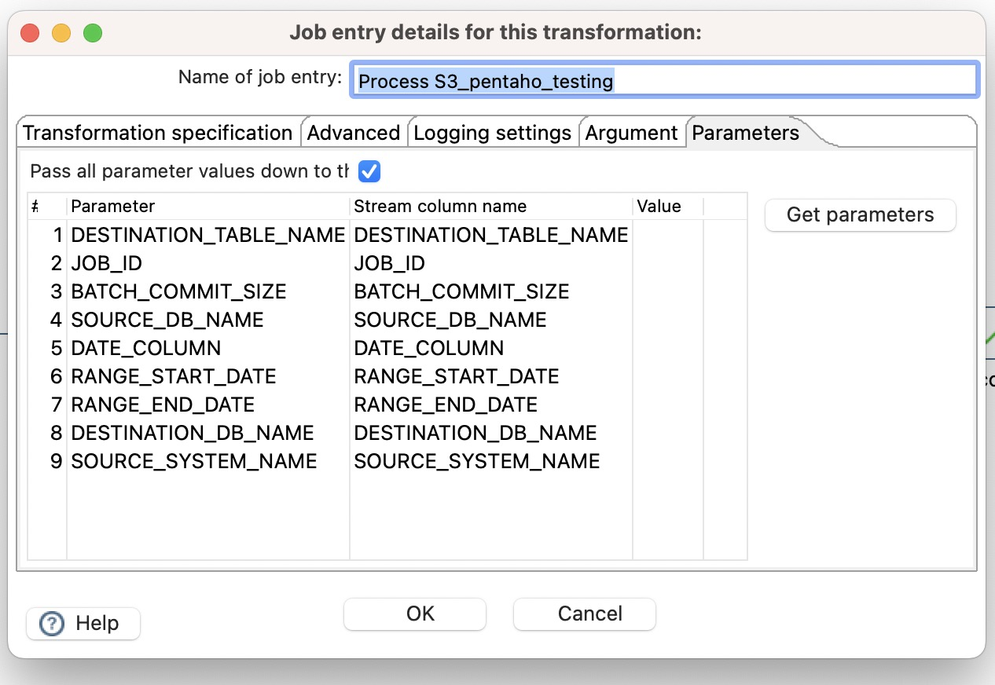
Parameter mapping is mentioned in “Parameters” tab for transformation step.

Transformation:
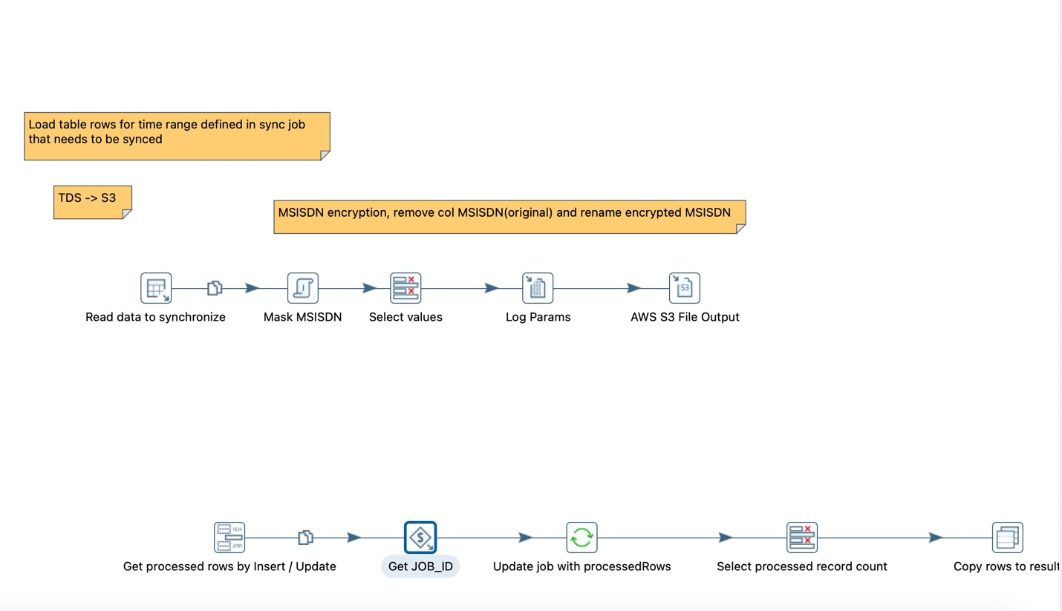

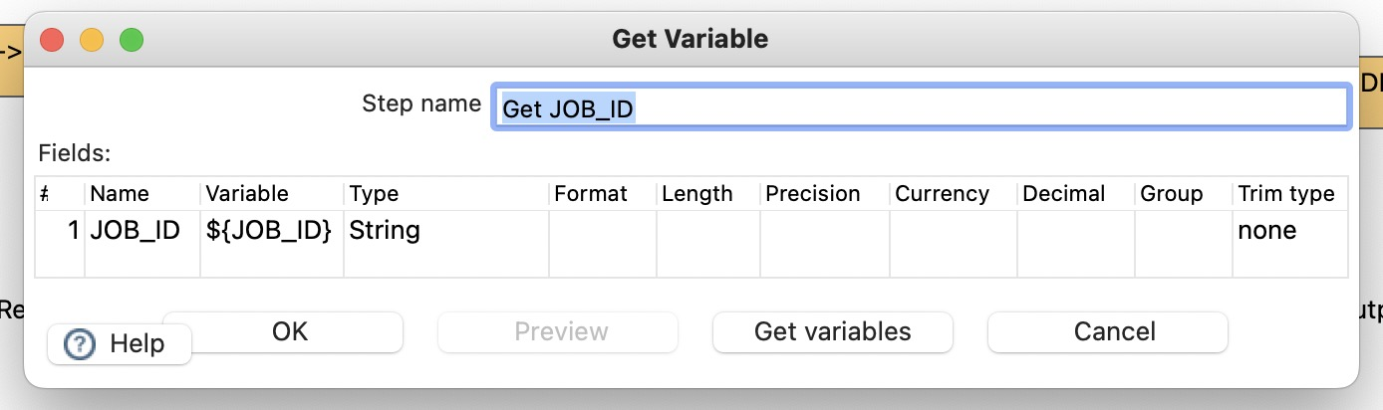

Transformation properties (parameter tab) :
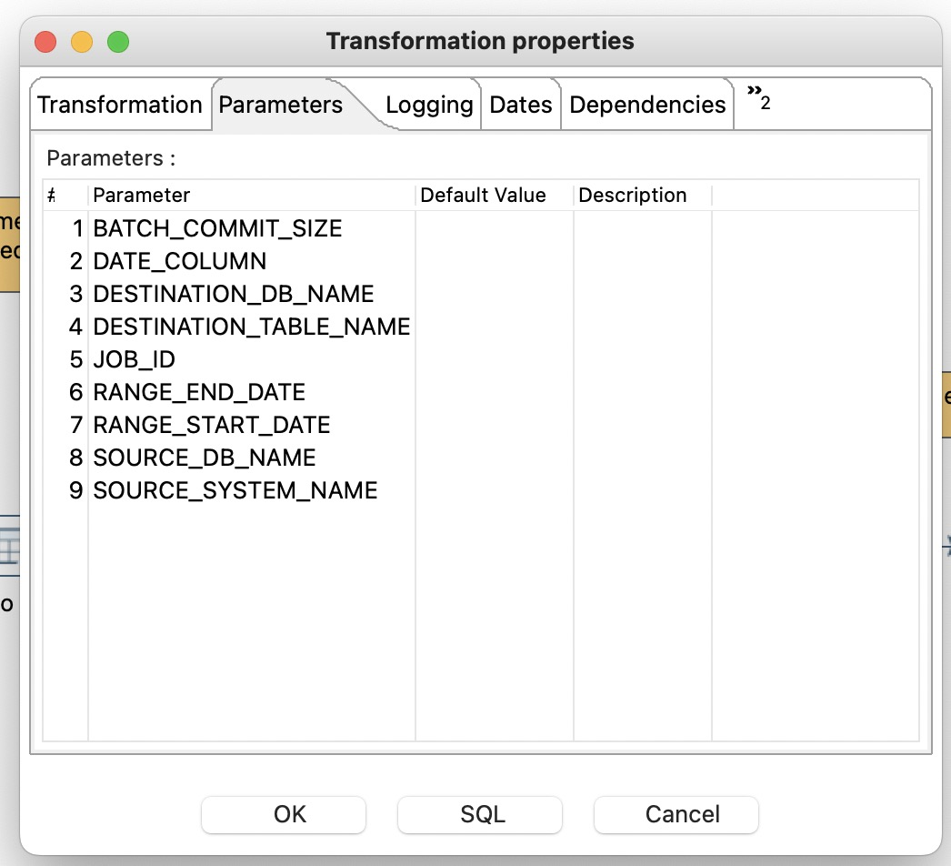

(also tried by removing variable names in transformation properties>parameters)
It fails to read JOB_ID (logs):

2023/12/05 14:55:29 - Get JOB_ID.0 - field [JOB_ID] has value []
2023/12/05 14:55:29 - Get JOB_ID.0 - Signaling 'output done' to 1 output rowsets.
2023/12/05 14:55:29 - Get JOB_ID.0 - Finished processing (I=0, O=0, R=1, W=1, U=0, E=0)
2023/12/05 14:55:29 - Update job with processedRows.0 - Checking row: [AWS S3 File Output], [S3FileOutputPlugin], [0], [2], [1], [0], [1], [0], [254], []
2023/12/05 14:55:29 - Update job with processedRows.0 - Field [JOB_ID] has nr. 9
2023/12/05 14:55:29 - Update job with processedRows.0 - Field [LINES_WRITTEN] has nr. 6
2023/12/05 14:55:29 - Update job with processedRows.0 - Setting preparedStatement to [SELECT processedRecords FROM etl_job_schedule WHERE ( ( ID = ? ) ) ]
2023/12/05 14:55:29 - Update job with processedRows.0 - Setting update preparedStatement to [UPDATE etl_job_schedule
2023/12/05 14:55:29 - Update job with processedRows.0 - SET processedRecords = ?
2023/12/05 14:55:29 - Update job with processedRows.0 - WHERE ( ( ID = ? ) ) ]
2023/12/05 14:55:29 - Update job with processedRows.0 - Values set for lookup: [], input row: [AWS S3 File Output], [S3FileOutputPlugin], [0], [2], [1], [0], [1], [0], [254], []
2023/12/05 14:55:29 - Update job with processedRows.0 - ERROR (version 9.4.0.0-343, build 0.0 from 2022-11-08 07.50.27 by buildguy) : Error in step, asking everyone to stop because of:
2023/12/05 14:55:29 - Update job with processedRows.0 - ERROR (version 9.4.0.0-343, build 0.0 from 2022-11-08 07.50.27 by buildguy) : org.pentaho.di.core.exception.KettleDatabaseException:
2023/12/05 14:55:29 - Update job with processedRows.0 - Entry to update with following key could not be found: []
2023/12/05 14:55:29 - Update job with processedRows.0 -
2023/12/05 14:55:29 - Update job with processedRows.0 - at org.pentaho.di.trans.steps.update.Update.lookupValues(Update.java:131)
2023/12/05 14:55:29 - Update job with processedRows.0 - at org.pentaho.di.trans.steps.update.Update.processRow(Update.java:319)
2023/12/05 14:55:29 - Update job with processedRows.0 - at org.pentaho.di.trans.step.RunThread.run(RunThread.java:62)
2023/12/05 14:55:29 - Update job with processedRows.0 - at java.lang.Thread.run(Thread.java:748)
2023/12/05 14:55:29 - sync_time_based_table_S3_pentaho_94_testing - ERROR (version 9.4.0.0-343, build 0.0 from 2022-11-08 07.50.27 by buildguy) : Errors detected!
2023/12/05 14:55:29 - Select processed record count.0 - Signaling 'output done' to 1 output rowsets.2023/12/05 14:55:29 - Update job with processedRows.0 - Signaling 'output done' to 1 output rowsets.

2023/12/05 14:55:29 - Copy rows to result.0 - Signaling 'output done' to 0 output rowsets.

