



CONFIDENTIAL – For use by Hitachi Vantara employees and other audiences under NDA only.

Query and Visualize Hitachi Mainframe Analytics Interpreter Data

**Using Amazon Athena and Grafana**

Hitachi Vantara

April 2023

© Hitachi Vantara LLC 2023. All Rights Reserved.



Table of  
Contents

Notices and Disclaimer 3

About This Document 4

Introduction 4

Intended Audience 4

Document Revisions 4

Comments 4

Introduction 5

Benefits 5

Architecture 5

AWS Location 7

AWS Identify and Access Management (IAM) Permissions 7

SFTP to Transfer Family 8

Create Host table in LPAR 8

S3 9

Transfer Family 9

Athena Database 12

AWS Glue 12

Installing Grafana 17

Installing Dashboard 17

Grafana Data Source Setup 19

HMAI Metrics 20

Grafana Reports 20

Drop Down Dynamic Variables 20

Storage Overview 21

Storage Configuration 21

AWS Cost and Usage Reports 23

# Notices and Disclaimer

© 2023 Hitachi Vantara LLC. All rights reserved.

No part of this publication may be reproduced or transmitted in any form or by any means, electronic or mechanical, including photocopying and recording, or stored in a database or retrieval system for commercial purposes without the express written permission of Hitachi, Ltd., or Hitachi Vantara (collectively, “Hitachi”). Licensee may make copies of the Materials provided that any such copy is: (i) created as an essential step in utilization of the Software as licensed and is used in no other manner; or (ii) used for archival purposes. Licensee may not make any other copies of the Materials. "Materials" mean text, data, photographs, graphics, audio, video, and documents.

Hitachi reserves the right to make changes to this Material at any time without notice and assumes no responsibility for its use. The Materials contain the most current information available at the time of publication.

Some of the features described in the Materials might not be currently available. Refer to the most recent product announcement for information about feature and product availability, or contact Hitachi Vantara at [https://support.HitachiVantara.com/](https://support.hitachivantara.com/en_us/contact-us.html) [en_us/contact-us.html.](https://support.hitachivantara.com/en_us/contact-us.html)

**Notice:** Hitachi products and services can be ordered only under the terms and conditions of the applicable Hitachi agreements. The use of Hitachi products is governed by the terms of your agreements with Hitachi Vantara.

By using this software, you agree that you are responsible for:

1. Acquiring the relevant consents as may be required under local privacy laws or otherwise from authorized employees and other individuals to access relevant data; and
2. Verifying that data continues to be held, retrieved, deleted, or otherwise processed in accordance with relevant laws.

**Notice on Export Controls.** The technical data and technology inherent in this Document may be subject to U.S. export control laws, including the U.S. Export Administration Act and its associated regulations, and may be subject to export or import regulations in other countries. Reader agrees to comply strictly with all such regulations and acknowledges that Reader has the responsibility to obtain licenses to export, re-export, or import the Document and any Compliant Products.

**EXPORT CONTROLS -** Licensee will comply fully with all applicable export laws and regulations of the United States and other countries, and Licensee shall not export, or allow the export or re-export of, the Software, API, or Materials in violation of any such laws or regulations. By downloading or using the Software, API, or Materials, Licensee agrees to the foregoing and represents and warrants that Licensee is not located in, under the control of, or a national or resident of any embargoed or restricted country.

Hitachi is a registered trademark of Hitachi, Ltd., In the United States and other countries.

AIX, AS/400e, DB2, Domino, DS6000, DS8000, Enterprise Storage Server, eServer, FICON, Flash Copy, IBM, Lotus, MVS, OS/390, PowerPC, RS6000, S/390, System z9, System z10, Tivoli, z/OS, z9, z10, z13, z/VM, BCPii™ and z/VSE are registered trademarks or trademarks of International Business Machines Corporation.

Active Directory, ActiveX, Bing, Excel, Hyper-V, Internet Explorer, the Internet Explorer logo, Microsoft, the Microsoft Corporate Logo, MS-DOS, Outlook, PowerPoint, SharePoint, Silverlight, SmartScreen, SQL Server, Visual Basic, Visual C++, Visual Studio, Windows, the Windows logo, Windows Azure, Windows PowerShell, Windows Server, the Windows start button, and Windows Vista are registered trademarks or trademarks of Microsoft Corporation. Microsoft product screen shots are reprinted with permission from Microsoft Corporation.

All other trademarks, service marks, and company names in this document or web site are properties of their respective owners.

IMPORTANT: This document can only be used as Hitachi Vantara internal documentation for informational purposes only. This documentation is not meant to be disclosed to customers or discussed without a proper non-disclosure agreement (NDA).

# About This Document

## Introduction

This document describes how to query and visualize Hitachi Mainframe Analytics Interpreter (HMAI) data using Amazon Athena and Grafana.

## Intended Audience

This document is intended for Hitachi Vantara staff and IT professionals of Hitachi Vantara customers and partners who are responsible for planning and deploying this type of solution.

## Document Revisions

|  |  |  |  |  |
| --- | --- | --- | --- | --- |
| Revision Number | Date |  | | Details |
| v1.0 | April 2023 |  | Initial release | |

## Comments

Send us any comments on this document to GPSE-Docs-Feedback@hitachivantara.com. Include the document title, including the revision level, and refer to specific sections and paragraphs whenever possible. All comments become the property of Hitachi Vantara Corporation.

Thank You.

# Introduction

Hitachi Mainframe Analytics Interpreter (HMAI) converts Mainframe analytics recorder records in an IBM z/OS® System Management Facilities (SMF) format to comma separated value (CSV) datasets. The CSV files contain mainframe performance information for key storage resources such as CLPR, MPB, Port, Parity Group, MPRank20, and LDEV.

HMAI Cloud includes components for automatically collecting MAR SMF data daily and writing CSV files to a mainframe file. The HMAI CSV files are then transferred to an AWS S3 Bucket from the z/OS LPAR using SFTP. After the S3 Bucket is populated, the CSV files are used to create an AWS Athena time series database. At this point, Grafana connects to the Athena database as a data source and visualizes the data using predefined dashboards.

## Benefits

The following lists the benefits of HMAI Cloud using Amazon Athena and Grafana:

* Metrics as time series graphs
* Predefined Grafana dashboards in Cloud or on-premises
* Ad-hoc customizable reports
* Low touch
* Low cost
* Trend analysis
* Serverless
* Warning and critical threshold alerts

# Architecture

The following provides an overview of the process that occurs when HMAI CSV data is created and transferred to the AWS Cloud before being analyzed with Grafana.

HMAI initiates an automated SMF DUMP job, which includes HMAI processing, on the LPAR to dump MAR user 191 records to an output file.

For the HMAI resources measured on the LPAR, HMAI collects user 191 SMF records as input and writes the HMAI CSV files as output. The resources include CLPR, MPB, Port, Parity Group, MPRank20, and LDEV.

The SMF dump automation includes a process that takes the HMAI CSV files as input and securely transfers them using SFTP to the AWS Cloud using the AWS Transfer Family as the SFTP site. Before writing the files, an SSH key must be generated for the LPAR and Transfer Family endpoints. To ensure a secure file transfer, a matching key pair must be defined for both the LPAR and AWS Transfer Family.

Before working with AWS, assign AWS IAM roles to access your S3 buckets for storing data transferred over SFTP. The IAM roles for installing HMAI Cloud requires the following permission policies:

* Amazon Athena Full Access
* Amazon S3 Full Access

Before beginning the installation, ask your AWS administrator to provide all permissions policies.

To SFTP files to the Transfer Family location, a Transfer Family endpoint IP address is required. For detailed instructions on how to define an endpoint IP address, see the Transfer Family section.

S3 Buckets are used to upload the SFTP CSV data as S3 Object data. As a best practice, ensure that the Bucket name is unique and refers to the LPAR name from which the data is being uploaded. After the Bucket name is created, define the S3 folder names with a lparname_resourcename naming convention, where resourcename is CLPR, MPB, Port, PGRP, MPRank20, and LDEV, all lowercase. For example, if the LPAR name is DV01, then name the bucket as hmai-dv01-bucket. In hmai-dv01-bucket, create folders named clpr, mpb, port, pgrp, mprank20, and ldev.

For details on how to create HMAI Cloud Buckets and Folders that are selected by AWS Family transfer, see the S3 section.

After S3 Buckets and Folders are created, use the AWS Glue Crawlers to perform an Extract, Transform, and Load (ETL) from S3 to an Athena database. Crawlers automatically create a database schema based on the format of the CSV files. After the Crawlers are defined, you can set up a daily scheduled Crawler. The Crawler schedule must run simultaneously with the SMF dump process. As a best practice, use the following convention for the Crawler names: lparname-resourcename-crawler. For example, the Crawler name for LPAR DV01 and Resource Port would be dv01-port-crawler. Note that to follow the AWS naming convention rules, the Crawler name must be in lowercase. When the Crawlers complete, the name of the Athena database that is created when setting up the Crawler reflects the LPAR name.

For example, use the Athena database name dv01, and refer to the S3 Folder name for LPAR DV01, hmai-dv01-bucket. Based on the examples for S3 Folders used previously, the Glue Crawler automatically creates the schema and tables for database dv01 as: clpr, mpb, port, pgrp, mprank20, and dev.

For details on how to create Crawlers that perform ETL for S3 data, see the AWS Glue section.

After defining the AWS services, use Grafana to point to the Athena database as a Grafana Data Source. The predefined dashboards for HMAI Cloud monitoring are provided as a JSON data source and are loaded in Grafana using the Dashboard Import function.

For details on how to setup Grafana in the Cloud, define the Athena database as a Data Source, and import the HMAI Cloud dashboard using Import JSON file, see the Grafana section.

The following figure shows the visual representation of the architecture.

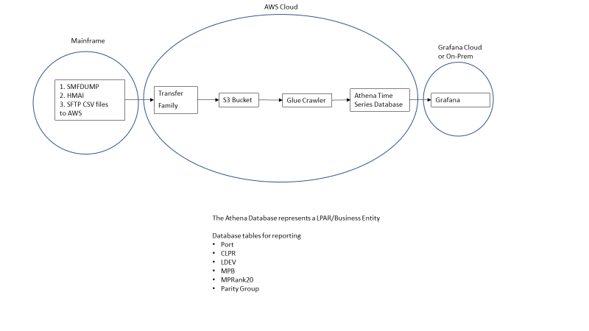

Figure 1: Architecture Details

# AWS Location

When defining AWS services, use the AWS location closest to your datacenter for improved latency. The following example shows US-WEST2 – Oregon used as the AWS service.



# AWS Identify and Access Management (IAM) Permissions

When defining AWS services, use the AWS location closest to your datacenter for improved latency.

For more information, see: <https://aws.amazon.com/iam/>

IAM policies and permissions are required to set up HMAI Cloud in AWS. Permissions policies must be defined before configuring any AWS services. The permissions policies used for defining HMAI Cloud in AWS are as follows:

* Amazon Athena Full Access
* Amazon S3 Full Access  
    
  Graphical user interface, application, Teams

  Description automatically generated

# SFTP to Transfer Family

Before configuring the Transfer Family in AWS, use Windows Putty Key Generator to create an SSH key pair. The key pairs are used in the mainframe and Family Transfer.

To generate an SSH key pair, complete the following steps:

1. To generate a public or private key pair, select the parameter type as RSA.  
     
   Graphical user interface, text, application, email

   Description automatically generated
2. Click **Save** **private** **key** with the .ppk extension.
3. In the Conversions selection, click **Export OpenSSHKey** and save the file with the .PEM extension.
4. Copy the PEM key to the mainframe. Run the chmod command and change the file to use permission 0700. For example,

chmod 0700 sshkey.pem

1. Select and copy the public key and paste it in the OpenSSH authorized_keys file section. This key is used to paste into the Transfer Family user SSH authorization.

## Create Host table in LPAR

When connecting to a File Transfer Server (AWS Transfer Family) for the first time from a new host (mainframe DV01), you must establish a list of known hosts, just as you would if you were connecting to a new Linux system for the first time as a user.

To create the mainframe host as a known host to AWS, enter the SFTP command using the SSH key and specify the AWS user.hostname to which you want to connect. When prompted to continue connecting and add the connection to the list of known hosts, click **Yes**.

For example, sftp -i sshkey.pem clpr@ (aws family transfer endpoint IP address).

# S3

For more information, see <https://aws.amazon.com/s3/>

To configure the S3 service, complete the following steps:

1. Log in to AWS console and select the S3 service.
2. Click **Create** **Bucket** and select the default option.
3. Add a Bucket name using the suggested naming convention. For example, hmaidv01-bucket.
4. In the same bucket, click **Create Folders**, and add the folders using the naming conventions of clpr, mpb, port, pgrp, mprank20, and ldev.

Because the Crawler process uses the folder name to create the tables within the database, it is important to add the folder names without any prefix. The table names are the same for each database, so Grafana can refer to the table names for reporting.  
  
When the folders are created, you will see them as folder names in the bucket.  
  
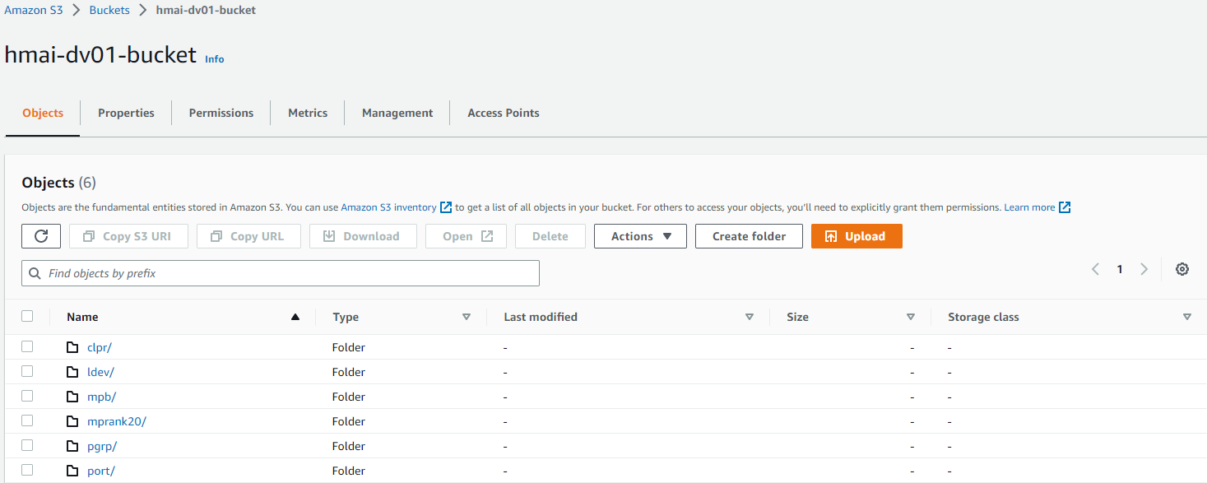

# Transfer Family

For more information, see <https://aws.amazon.com/aws-transfer-family/>

To configure the AWS Transfer Family, complete the following steps:

1. Log in to AWS Console and select Transfer Family.
2. Select the protocols you want to enable as SFTP.Graphical user interface, text, application, email

   Description automatically generated  
     
   

Note the Endpoint ID because. You will use it when defining the Endpoint on the Mainframe.

1. Click **Add user** and add a user for each HMAI SFTP resource using the suggested naming conventions. For example: hmai-dv01-clpr, hmai-dv01-ldev, hmai-dv01-mpb, hmai-dv01-mprank20, hmai-dv01-pgrp, and hmai-dv01-port.
2. Select the Role for Amazon S3 access and specify the Policy as None.
3. Select the Home Directory created for the S3 Bucket.  
   The Bucket created in S3 was named hmai-dv01 in the following example:  
     
   Graphical user interface, text, application, email

   Description automatically generated
4. In the SSH public key window, copy and paste the SSH public key created by PuttyGen.  
   Graphical user interface, text, application, email

   Description automatically generated

# Athena Database

For more information see <https://aws.amazon.com/athena/>

To configure the AWS Athena database, complete the following steps:

1. Log in to AWS Console and select AWS Glue.
2. In the left navigation pane, select Databases.  
     
   Graphical user interface, text, application, chat or text message

   Description automatically generated
3. In the Database panel, click **Add database**.  
     
   
4. Using the suggested naming convention such as dv01, create a database, and click **Create database**.  
   Note that the database name is used in the next steps to create Glue Crawlers.  
     
   Graphical user interface, application

   Description automatically generated

## AWS Glue

For more information, see <https://aws.amazon.com/glue/>

To configure the AWS Glue Family service, complete the following steps:

1. Log in to AWS Console and select AWS Glue.
2. In the left navigation pane, select Crawlers.  
     
   Graphical user interface, application

   Description automatically generated
3. In the Crawlers panel, click **Create Crawler** and follow the wizard prompts.
4. Enter the Crawler Name. Use the naming conventions for each Crawler name associated with an HMAI Cloud resource. For example, dv01-clpr-crawler, dv01-ldev-crawler, dv01-mpb-crawler, dv01-mprank20-crawler, dv01-pgrp-crawler, and dv01-port-crawler.  
     
   Graphical user interface, application, email

   Description automatically generated
5. In the Choose Data Sources and Classifiers window, select Not yet and click **Add a data source**.  
     
   Graphical user interface, text, application, email

   Description automatically generated
6. When prompted to choose the S3 path, select hmai-dv01-bucket > clpr, and click **Choose**.  
     
   Graphical user interface, application

   Description automatically generated
7. To add a data source, click **Add an S3 data source**.  
   Note that when the S3 path is displayed, there must be a **/** at the end of the path name.Graphical user interface, text, application, email

   Description automatically generated
8. Create a new IAM role and name it AWSGlueServiceRole-dv01-clpr. Select the newly created role, select the defaults, and click **Next**.

1. In the Set output and scheduling window, select the Target database dv01. For testing, select the Crawler schedule as On demand, and click **Next**.  
     
   Graphical user interface, text, application, email

   Description automatically generated
2. Review and create.
3. Review the defined settings.
4. If any settings require modifications, click **Edit**.
5. To create the dv01-clpr-crawler, click **Create Crawler**.
6. Repeat the procedure for Crawlers dv01-mpb-crawler, dv01-mprank20-crawler, dv01-pgrp-crawler, and dv01-port-crawler.  
     
   Graphical user interface, application

   Description automatically generated

# Installing Grafana

For installing Grafana, we used a free account of Grafana Cloud. To create a free account, log in to Grafana and click **Free Account setup**. When your account is ready, navigate to Dashboards and follow the Install dashboard procedure.

## Installing Dashboard

To install dashboard, complete the following steps:

1. Request HMAI Cloud from the JSON Dashboard file and import it to Grafana by selecting **Dashboards** > **New** > **Import**.  
     
   Background pattern

   Description automatically generated
2. When prompted, paste the file to the **Import via panel json** section and then click **Load**.
3. When the dashboard loads, navigate to the Grafana Dashboards list, and select the **Hitachi Mainframe Analytics Interpreter** dashboard.

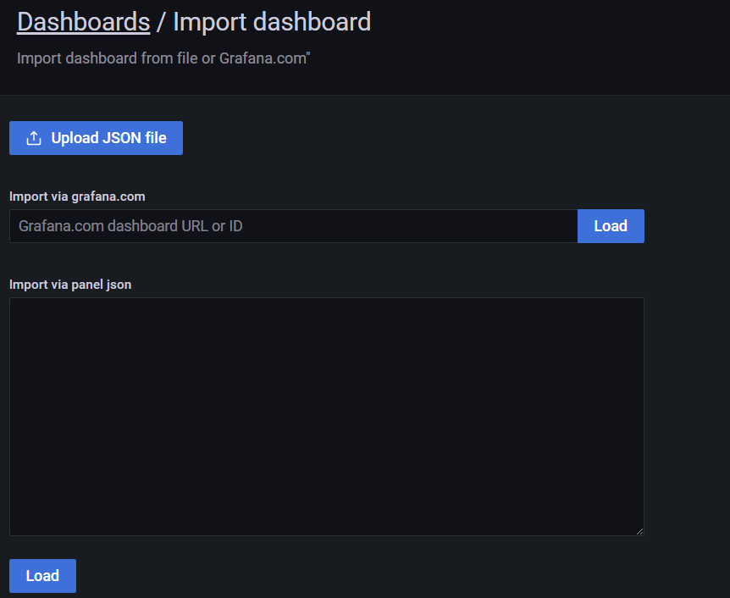

1. Navigate to **Dashboards** > **Browse**, and then select **Hitachi Mainframe Analytics Interpreter**.

You will see an icon indicating the Dashboard is loading. Wait for a few minutes for the dashboard to display. Loading time may vary because Grafana is entering the Athena database information. After the data is loaded from Athena, it is cached in Grafana and subsequently displays the data.

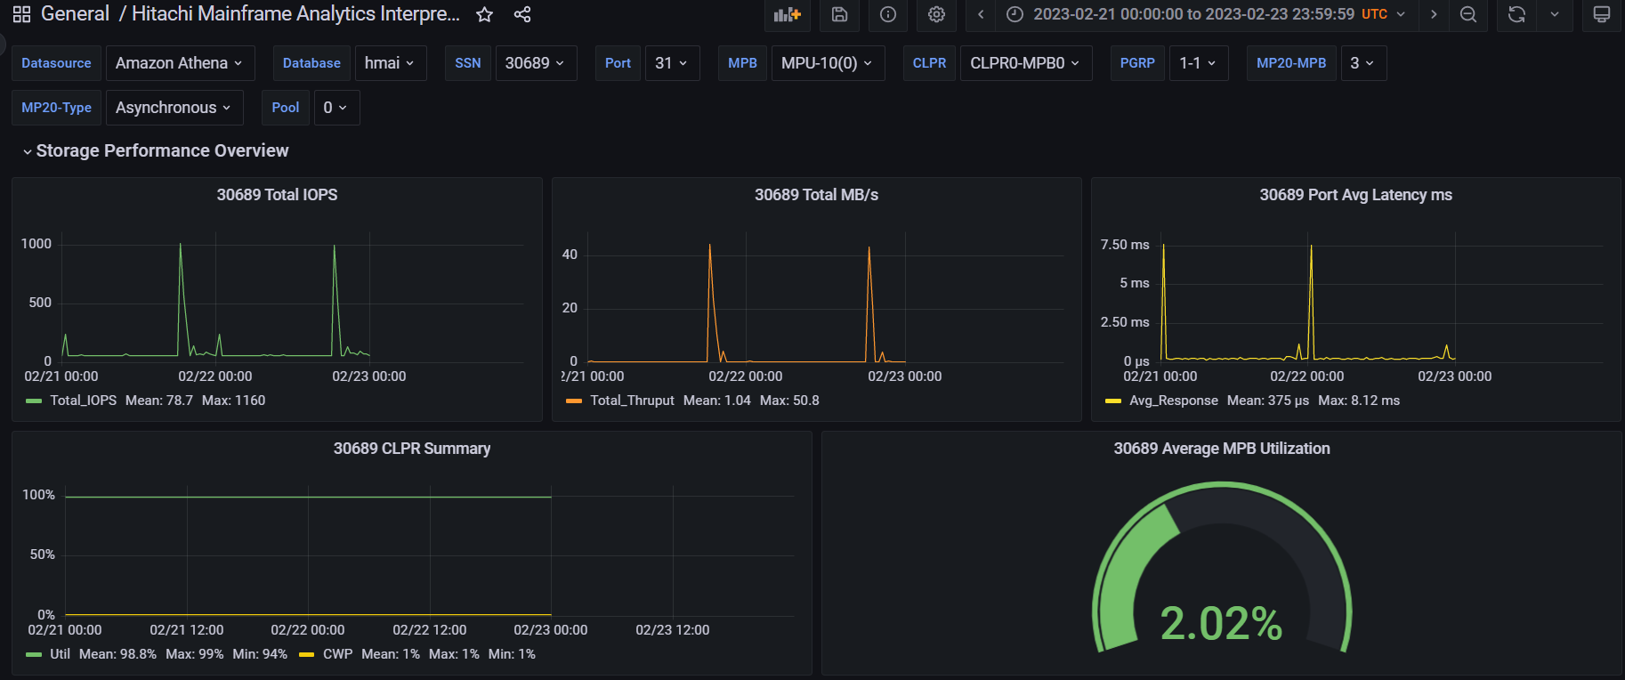

## Grafana Data Source Setup

1. Before loading the dashboard, verify whether the Amazon Athena datasource is selected in Grafana configuration.
2. Enter the Access key ID and Secret Access key information obtained from AWS Cloud source. For information on Athena, navigate to AWS Console and select the Athena service.
3. Use the first LPAR database as your database source. You can change the database using the Grafana dashboard. In the example, the default Athena Database name is hmai.
4. For Data source and Workgroup, use the default values.

# HMAI Metrics

For a detailed explanation of all the available HMAI metrics, see [Mainframe Resource and Metrics Data Dictionary.xlsx](https://community.hitachivantara.com/HigherLogic/System/DownloadDocumentFile.ashx?DocumentFileKey=489af661-0a7f-ff3c-7fb5-47bb90edd4e4&forceDialog=0).

# Grafana Reports

## Drop Down Dynamic Variables

Every time a new database and SSN are selected, the variables used for viewing the dashboard reports are dynamically updated. This allows for detailed examination of storage resources and keeps the configuration information up to date. For example, the MPB drop-down menu displays all available MPBs for the selected SSN if one or more MPB analysis are required. Several MPB time series graphs are displayed when more than one MPB is selected in the drop-down menu.

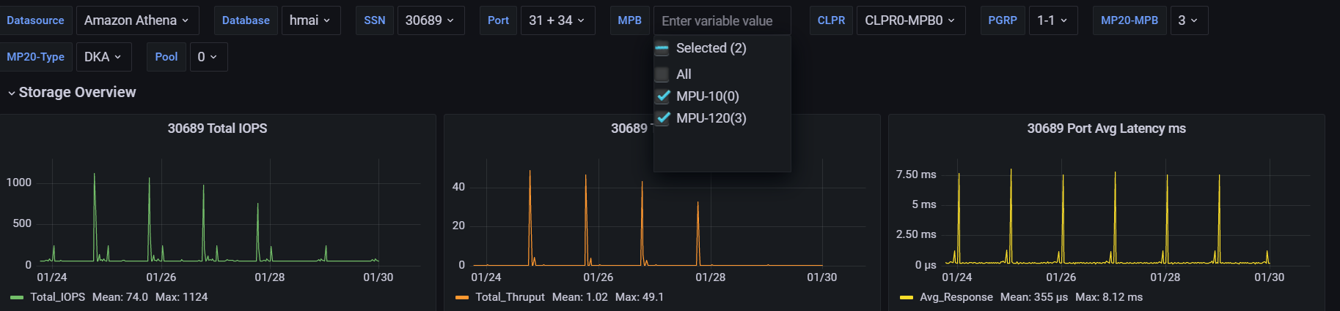

## Storage Overview

Key performance metrics show Total IOPS, Total Throughput, Port Latency, Cache Logical Partition (CLPR) utilization, and MPB utilization. Depending on the usage, resources can be further examined by Port, MPB, CLPR, MPRANK20, Parity Group, and Pool.

## Storage Configuration

Detailed Storage Configuration information is displayed for Port, Parity Group, and LDEV. This information is used to match storage resources to mainframe resources. For example, LDEV configuration displays the LDEV ID alongside the Mainframe Device Number and Volume Serial Number. In depth analysis of Hitachi mainframe storage systems is possible by combining the configuration data with performance graphs.

**Port:**

**MPB:**

**CLPR:**

**MPRANK20:**

**PGRP:**

**Pool:**

# AWS Cost and Usage Reports

After HMAI Cloud is installed, use AWS Cost and Usage Reports to view the cost associated with AWS Cloud.

For more information on AWS cost and usage reports, see <https://aws.amazon.com/aws-cost-management/aws-cost-and-usage-reporting/>

For more information on Query and Visualize AWS cost and usage data, see <https://aws.amazon.com/blogs/big-data/query-and-visualize-aws-cost-and-usage-data-using-amazon-athena-and-amazon-quicksight/>